INFO3315

**Human-Computer Interaction**

**Project Phase 2**

Group Members (SID):

XIAOHAN LI(470011746)

XIHE HU(460047977)

ZELIN YE(490444409)

R16C - Group 5

# 1. Object/Operation Analysis

(a)

|  |  |  |
| --- | --- | --- |
| **Objects** | **Attributes** | **Operations** |
| Person | Name, SID, Photo, Address, Phone, Email, Subject, Description | View details, Log out, Give feedbacks, Change the setting |
| Map | Description, Location, Duration, Identification, Signal | Navigate users, Edit attributes, Examine |
| Timetable | Description, Time, Location, Duration | Examine, Interact with Map, Edit attributes |
| Calendar | Time, To-do item, Description, Deadline, Status | Examine, Interact with Map, Edit attributes |
| Setting | Description, Status | Examine, Edit attributes |
| Feedback | Description, Location, Transportation, Time | Examine, Interact with Map, Edit attributes |

(b)

1. Basic Sketch Elements

Lines, Rectangles, Triangles, and circles.

1. Composing Objects

Tools (pens, pencils, scissors)

Document (paper, books, map, timetable, calendar, schedule)

Digital Device(camera, computer mouse)

Physical Object(bulb, boxes, clock)

Abstract Shapes(signals, feedback, setting)

1. People(person)
2. Activities (Whatever)
3. Bodies and Emotions (surprised, confused, angry)
4. Faces and Emotions (normal, happy, sad, angry)
5. Combining Postures and Faces (surprised, angry)
6. Combining Different Sketch Elements to Illustrate Situations (Whatever)

(c) #The final vocabulary versions are attached in appendix 1 at the bottom of the report.

# 2. Initial conceptual model

(a) #Metaphors are in the appendix 2 at the bottom of the report.

(b)

1. Conversing: when the user needs to use the navigation mode of the app, conversing as an interaction type would be very helpful, since when walking or driving, it will be much safer and convenient if users can set their routes without looking their screens.

2: Responding: different users have different personalities and preferences; the app need to automatically analysis which type of recommendation can give to several people (e.g. If the user prefers trains, the route will more likely to let the user take trains, if the user is at free time, the route will more likely to let the user go through recreation area to rest)

3: Manipulating: like most apps the user need to move, select, drag, open different elements. If our apps have the same feature as this, the users are more likely to learn how to user the app faster.

(c)

Manipulating is the interaction types that have more advantages, it can be designed to have general purposes, no matter the user wants to navigate themselves, set their to do list or customize their settings, they can direct manipulate the system, and the system can easily understand that. It gives continuous representation of the objects and actions of interest.

(d)

The main metaphor is Map, and interaction style is manipulating, since the main purpose of using this app is to plan daily commute, so navigation mode needs to be highlighted, and with manipulating the map, drag it until the place the user wants to go is in the center, or just type the location, the route can automatically generate. And if the user wants to add further information like when to go or which route can be cheaper, or which takes shorter time. They can click the route and type these in. These actions can be done without any thinking mostly, because this is the way people thinking when they want to plan daily commute, think the places want to go, then when to go, after that, which route is better.

# 3. Expanding the Conceptual Model

(a)

* Product - GPS coordinates, navigation, and tracking

- Routes arrangement

- Duration estimation

- Error reporting

- Settings applying

- Calendar and timetable processing

- Different transportations providing

- Feedbacks processing

- Voice prompting

Human - Feedbacks giving

- Routes choosing

- Settings change

- Transportation choosing

- Information(address, timetable, calendar, etc.) providing

- Photograph providing

- Log in/off

- Interacting with other users

* - Setting: 1. Voice prompt or not

2. Allowing access to camera or not

3. Allowing access to the current location or not

4. Text, Icon size

5. Save the location or not

6. Avoiding someplace(toll, highway, etc.) or not

7. Personal information editing

8. History record of address

9. Notice or not

- Routes: (temporary) Routes choosing

- Feedback: Feedbacks editing

- Transportation: (temporary) Transportation choosing

- Account: Log in/off, photograph

(b)

Partial Sequential: Login -> GPS -> Transportation & Duration -> Routes & Duration -> Navigation & Voice prompting

Partial Parallel: Timetable and Calendar & Settings & Feedbacks & Personal information editing

Categorizations: GPS & Photograph access & Internet connection & Notification access

(c)

- Real-time data about Sydney transportation and road condition -> GPS

- Real-time user location -> GPS

- Uniwide detailed information -> USYD data warehouse

- Timetable and calendar -> Data integration (Structured data)

- Personal information/ Feedbacks -> Unstructured data

# 4. Validating the Conceptual Model

(a) #The 6 storyboards are in the appendix 3 at the bottom of the report.

(b)Student: The feature of connect different locations in one route looks very handy, but can the system decide the priority of these locations?

Student: How about the orders of these locations?

Student: what if the system guides them to a place without signal?

Student: I can’t trust it, these programs can go wrong sometimes

Student: I don’t like the program decide by themselves.

Student: This looks so cool, it’s like I have a housekeeper to remind me all these things.

Student: No, I don’t think anyone can forget an assessment, this feature is useless.

Student: How long can these messages store, if it’s too long my phone could filled with it

Student: I probably need it; my memory is very bad.

Student: The share feature can also tell others how to get there, that’s convenient.

Student: It’s useless, why not just tell them, they are not dumb, they can find it.

Student: If Mike choose a place like mountains to have picnic, the GPS signal probably won’t support this.

Student: Why don’t I use Facebook or text instead of using this chat button, there’s nothing new in it.

Student: The system connected with the school; so, the information would be trustworthy.

Student: So, is that we use this chat button to everyone have this app or just people we know?

Student: I think this feature is the same with “share” feature.

Student: It’s good that we ca use this to make more friends.

Student: I don’t know is it possible for people to like a route?

It would be very nice to let this feature can also apply to the people who don’t have this app.

(c) #The two refined boards and statements are in the appendix 4 at the bottom of the report.

1. As the feedback of ‘but can the system decide the priority of these locations?’, so in this story board we make the system have the feature of define which location comes first, which location come to next, the user can set it freely.
2. As the feedback of ‘It would be very nice to let this feature can also apply to the people who do not have this app.’ The app would have the new feature of upload routes to the people who do not have this app, which strengthen the social part of the app.

**5. Paper prototype**

Three tested users - one single male, one single female, one couple.

(a) #The paper prototypes are scanned and attached in the appendix 5 at the bottom of the report.

(b)

1. The first software we designed was intended to be simple and accessible to users with a lower version of the phone. However, according to our user tests, they all felt that it was too simple, there was no picture beautification and no sense of use and wanted to add a favorite restaurant or entertainment module.
2. In the second software, we added some sense of design, such as putting ICONS in front of each module. A special mini-map has been added at the bottom to allow users to see their location and surroundings at any time. Users said the design looked advanced and the whole page was much prettier than the previous one, but the practicality and complexity were doubted.
3. In the third design, we refer to the most popular and similar function software nowadays and some improvements have been made to its page design. We have removed many unnecessary functions such as sending and receiving information. Many users say that the software is beautiful and simple, because the icons are bigger, but wanted to add a favorite restaurant or entertainment module.
4. The fourth software we want to give users a sense of experience in their own exclusive space, so we give the user information the most typesetting. But users have said that personal information takes up too much space and lacks many features such as settings, bookmarks and help modules.
5. The fifth section of our design philosophy is for users who are pursuing fashion design. After all, this software is for young people. But most users say that this design is very fashionable, but it is not convenient to click. And for some users who do not use a full-screen phone will be very inconvenient and wanted to add a favorite restaurant or entertainment module.

(c)The second and third software are the best in the user evaluation, the overall design is beautiful and simple, and there is no lack of necessary modules. And more importantly, users feel that these two designs should be convenient to use, which is in line with our design.

(d) #The paper prototypes are scanned and attached in the appendix 6 at the bottom of the report.

In our user’s test, almost every design user mentioned that they would like a bookmark module. We believe that a bookmark module could increase the usability and user experience of our design, so we added it in these two designs. For the second design, we delete the menu bar icon because the design is simple and clear enough, there is no need to hide some functions. What’s more, we add a ‘help’ icon and a ‘setting’ icon for the third one and a ‘setting’ icon for the second one.

(e) We once again give the two improved software to the users. When we describe the function of the software to the users again, the users do not have much defects on the second design but hope to put the feedback module in the main position. A user suggests that if we repeatedly mention that our software has feedback function, she feels that it needs to be in the main position. And the users questioned the third software. Since our map icon is an Earth, one user said that although he heard our introduction, this is a campus software, but this icon of our design makes him feel this software is available worldwide.

(f) #The paper prototypes for the second design is scanned and attached in the appendix 7, for the third design is scanned and attached in the appendix 8 at the bottom of the report.

(g) We show our more detailed design to the users, and the users unanimously say that the second design is more practical than the third one. In particular, the feedback interface of the third design makes them very confused. They almost always ask what that my feedback is. And the users agree with the details of the second design, such as the estimated time of the navigation interface and the calendar edition etc. Obviously our third design is not very successful, especially the feedback interface design. Two of the users suggested that we need to add a school icon. Because this is a campus software, if the user has transferred school or changed schools, they can find and change in time to get the information of the school where they are.

(h) #The paper prototypes are scanned and attached in the appendix 8 at the bottom of the report.

After user review, we found that the second model is our best design and the most practical one by comparison. The second design has a greater number of votes which is 8 when we hold a vote with 10 users with different contents depend on their travel mode and sense of direction. The main reason they choose the second one is because it is more detailed, functional and special than the third one. They think the third one is similar to the ordinary navigation tool so that they have no reason to change the old one to this new application.

Based on the last user test, the users are afraid of that the mini map may not be so useful as it seems because it occupies too little space, the size of field of view was questioned. As a result, we resize the map to one-third instead of one-fifth of the page. What’s more, we chose to add the school icon, because we obtain information from the system of every cooperating school. We’d like to let user clarify the school, or it would mean the greatly reduce the practicability of our software.

# 6.Appendix

# Appendix 1:

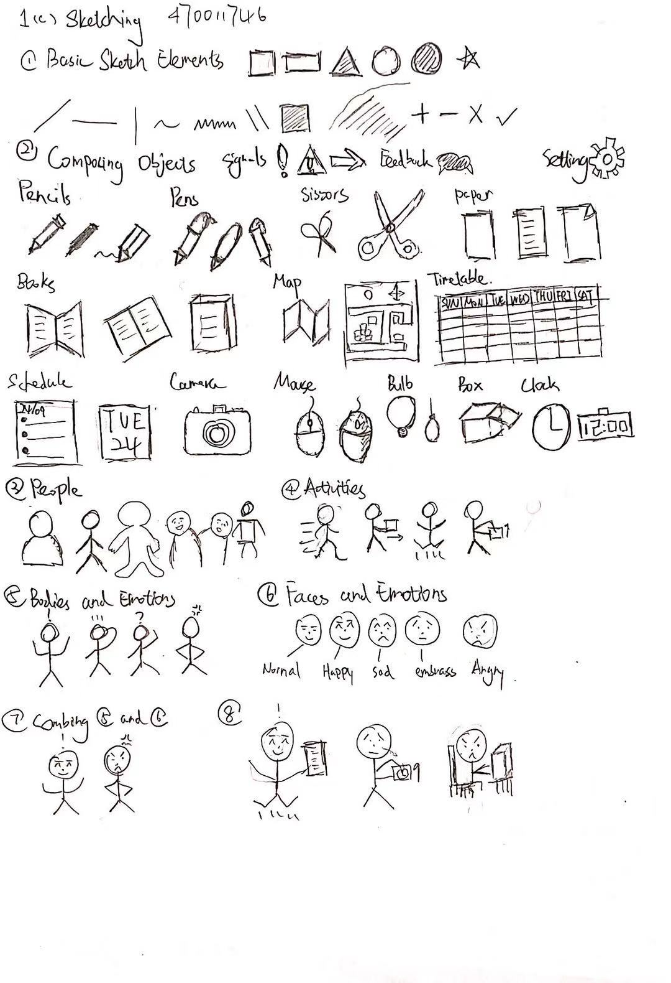

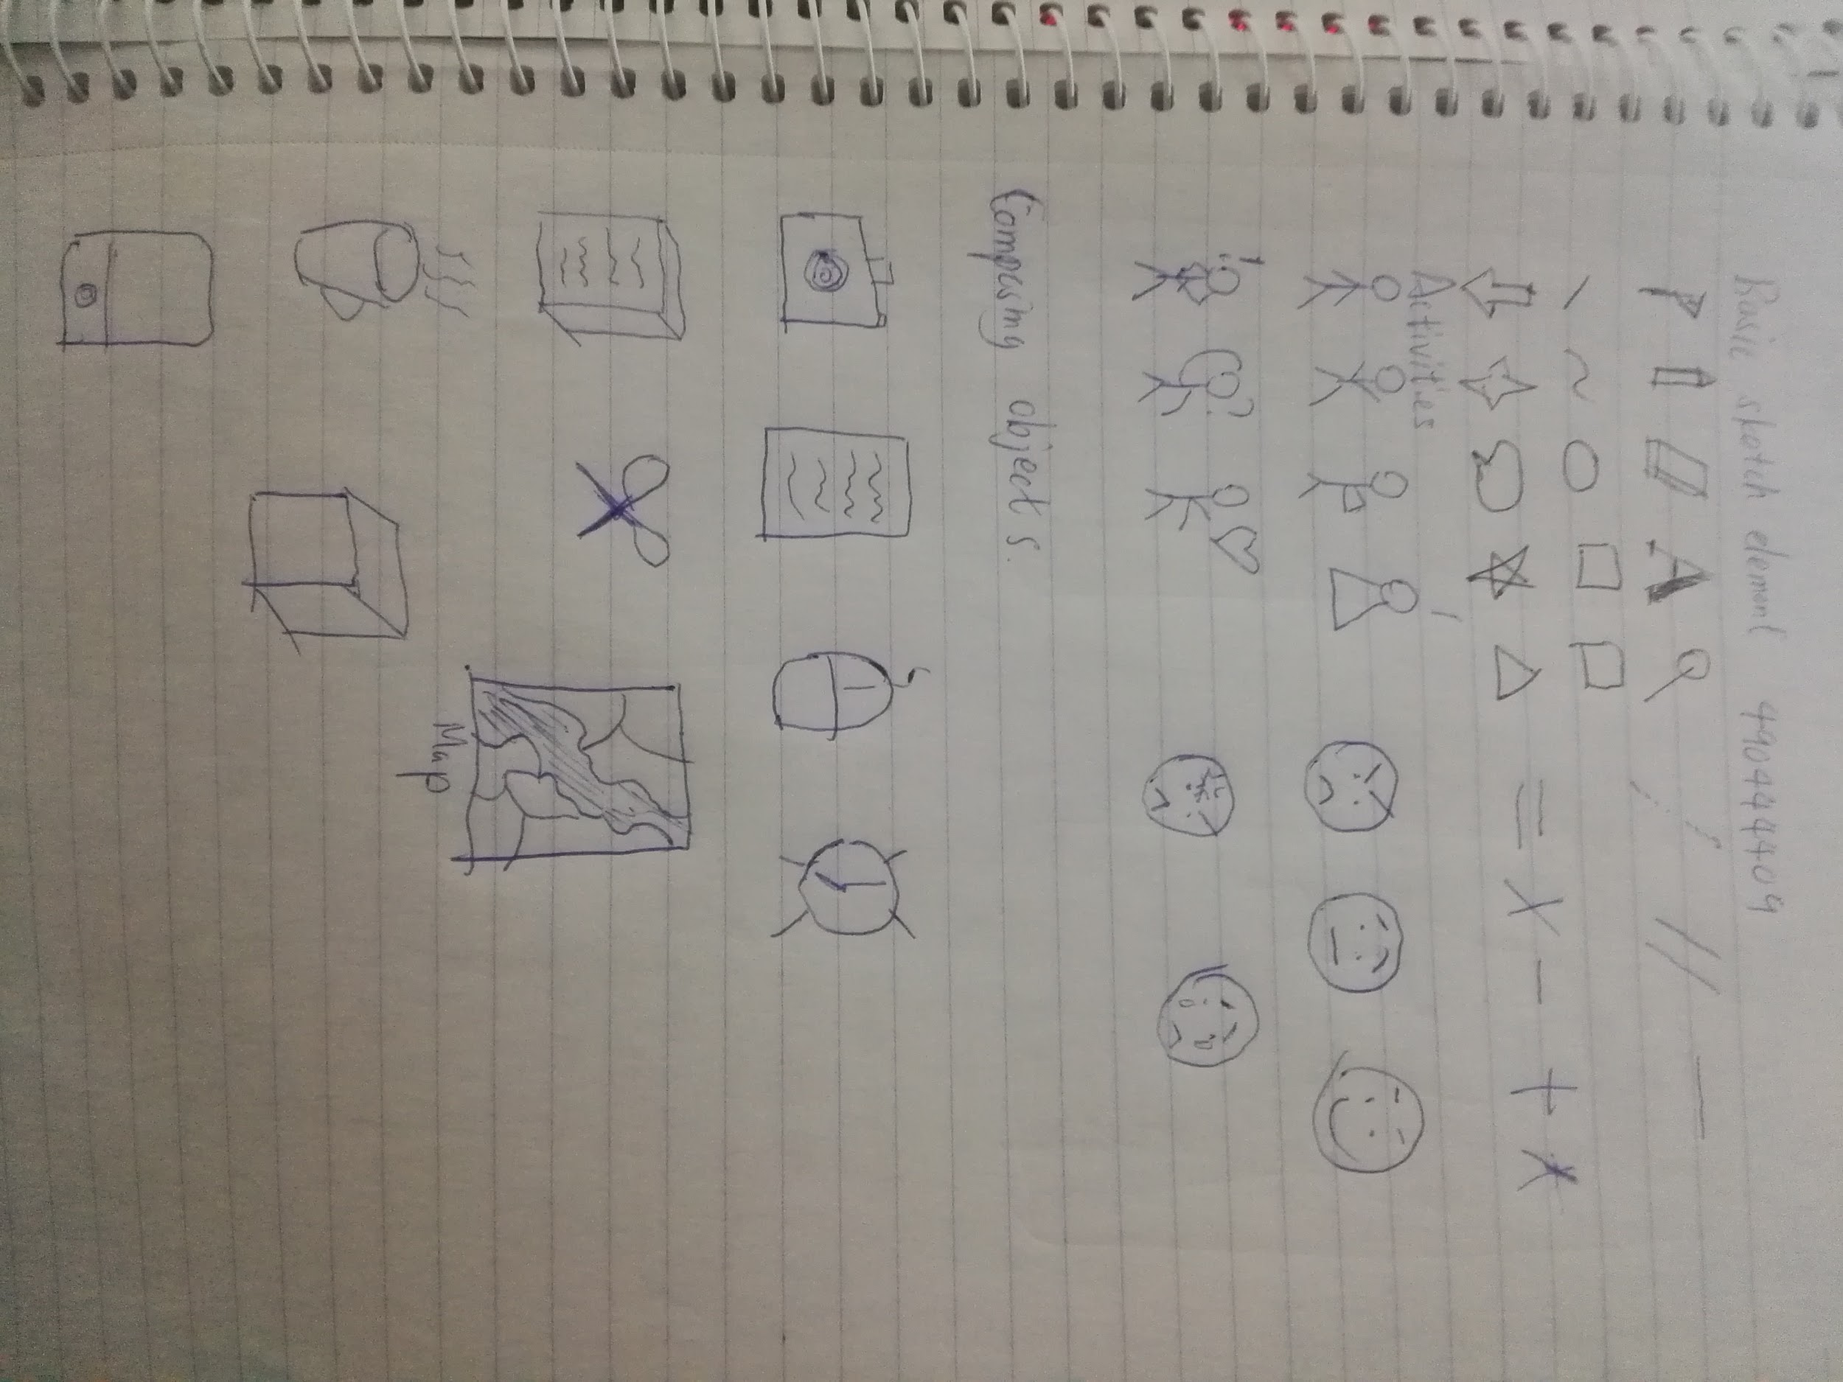

Appendix 2:

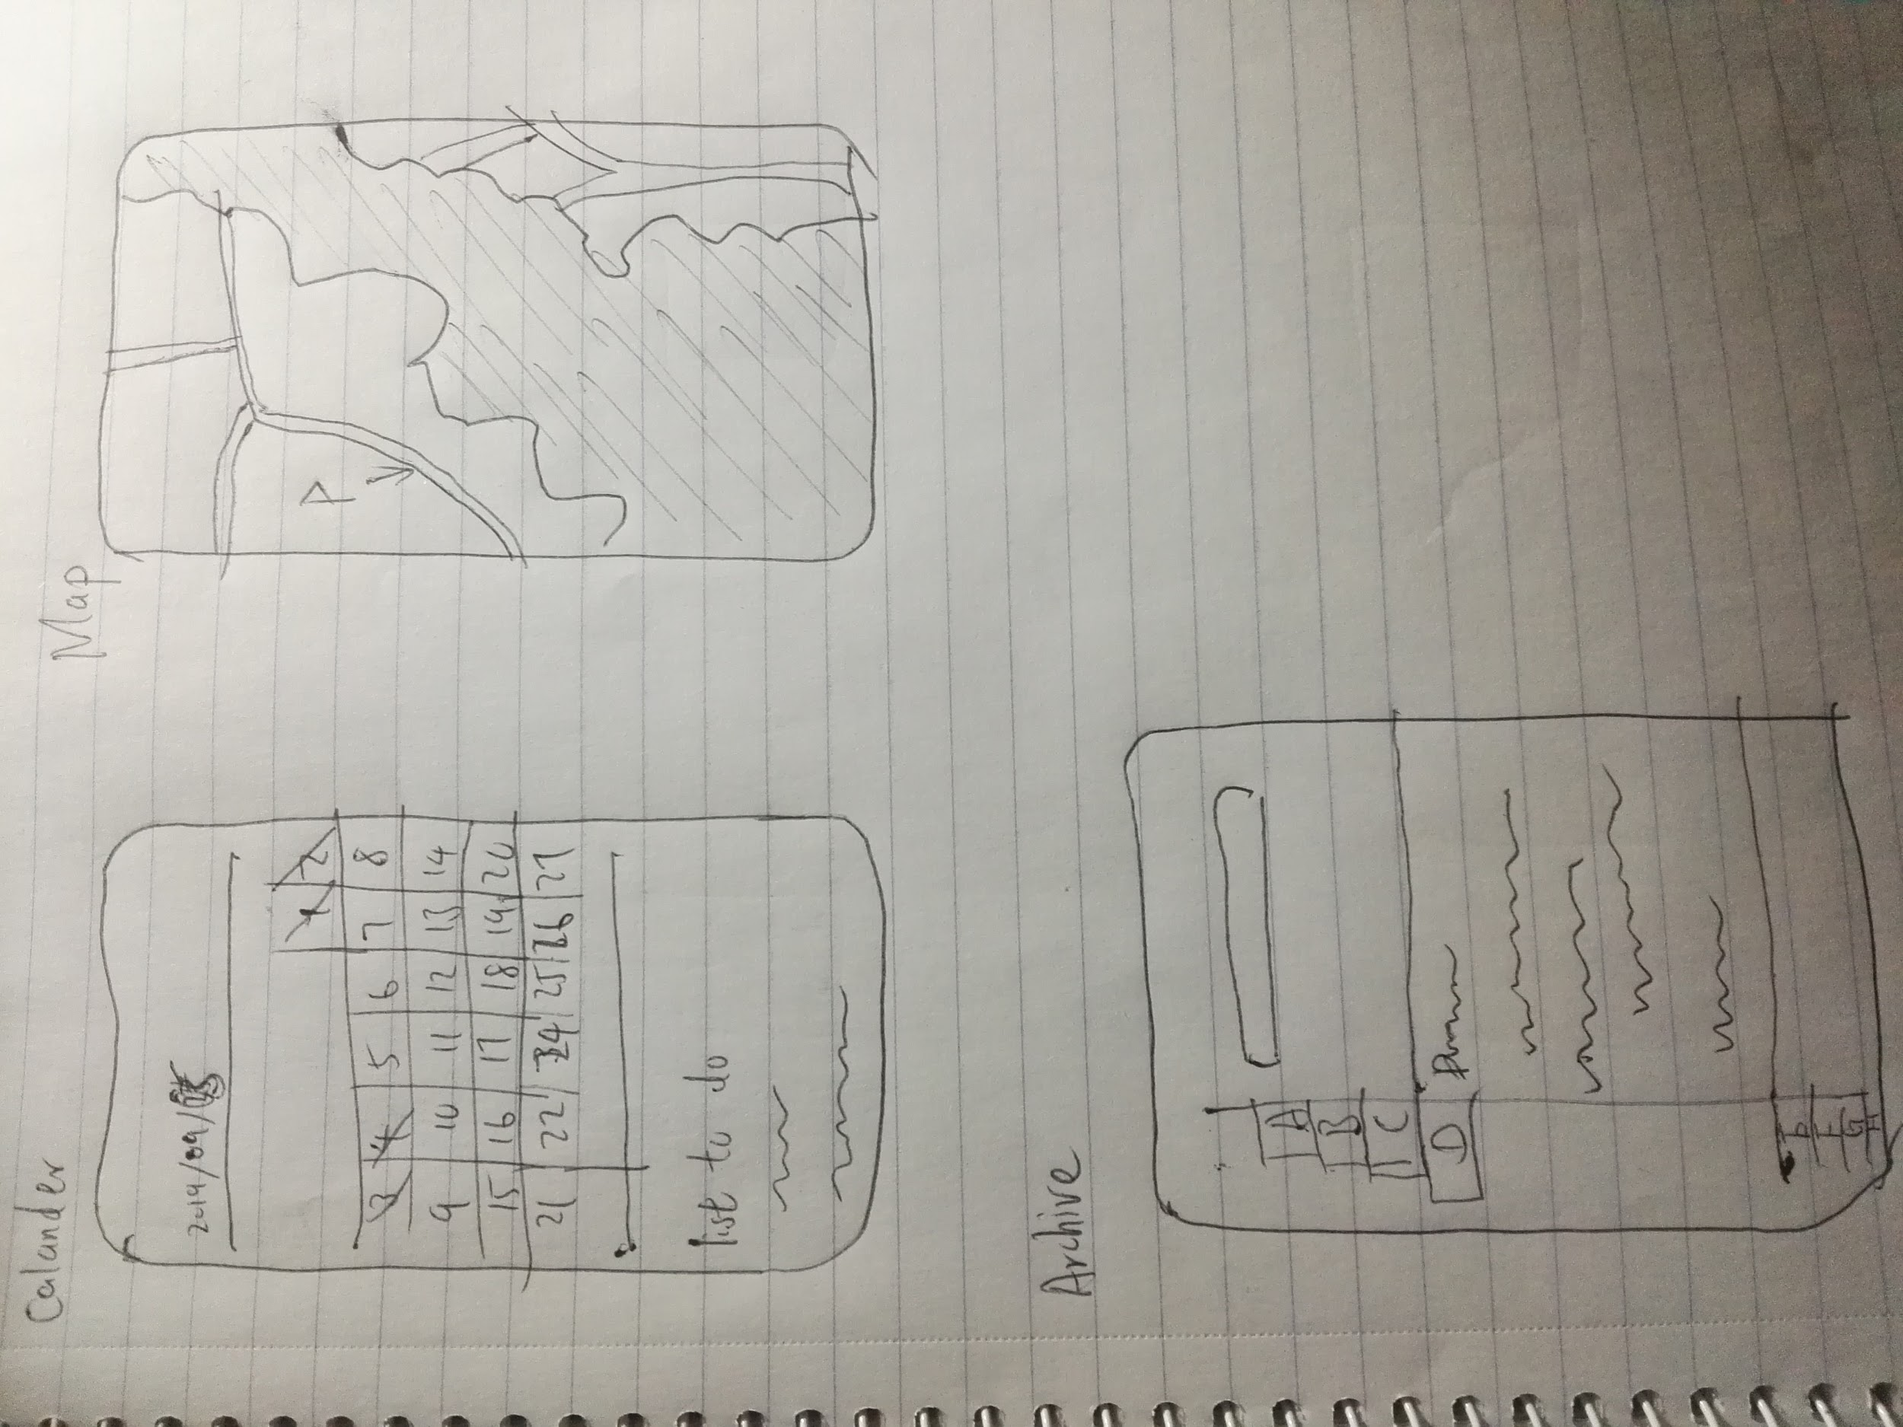

Appendix3:

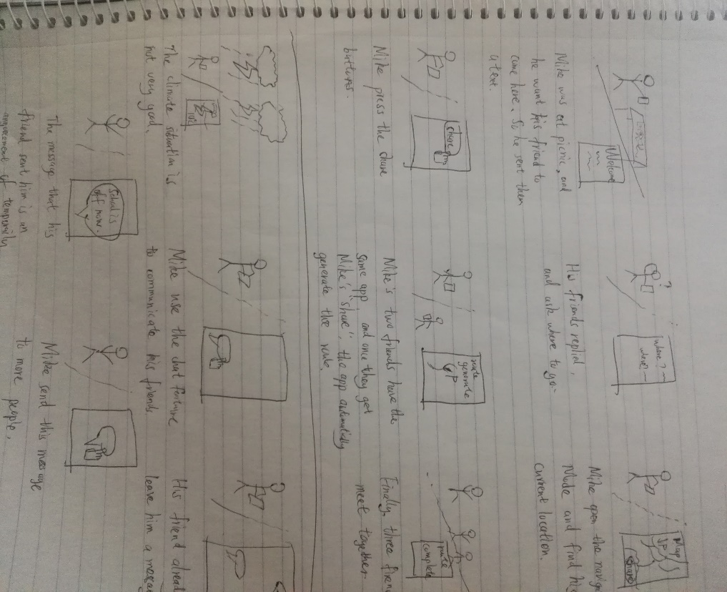

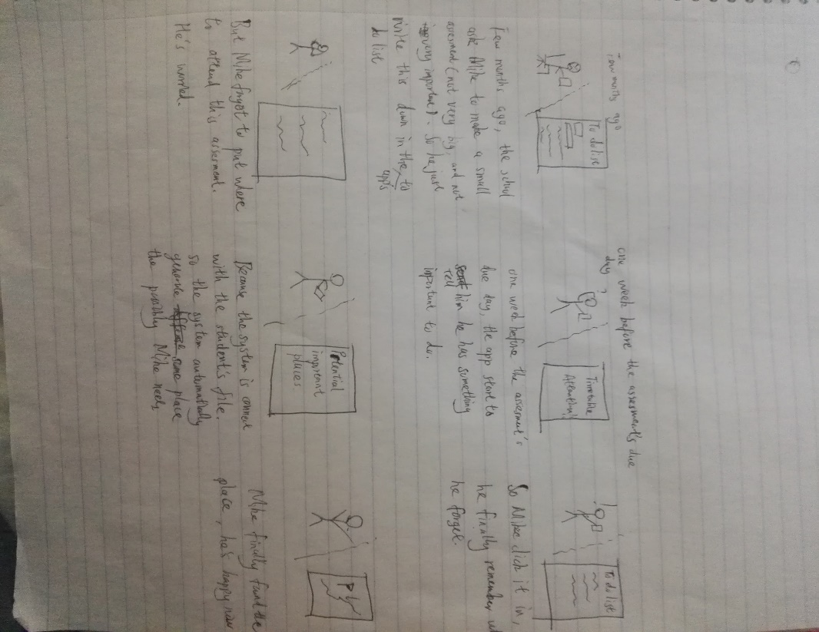

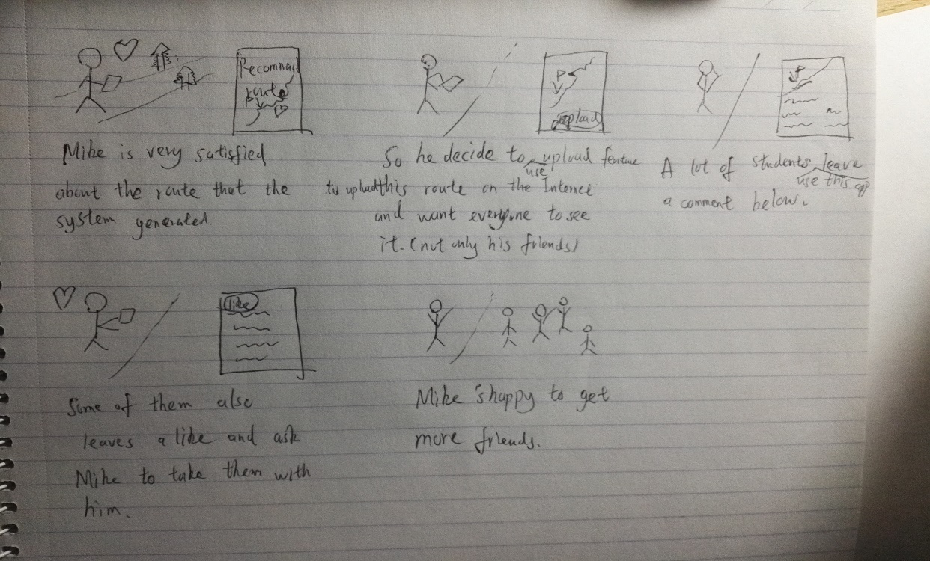

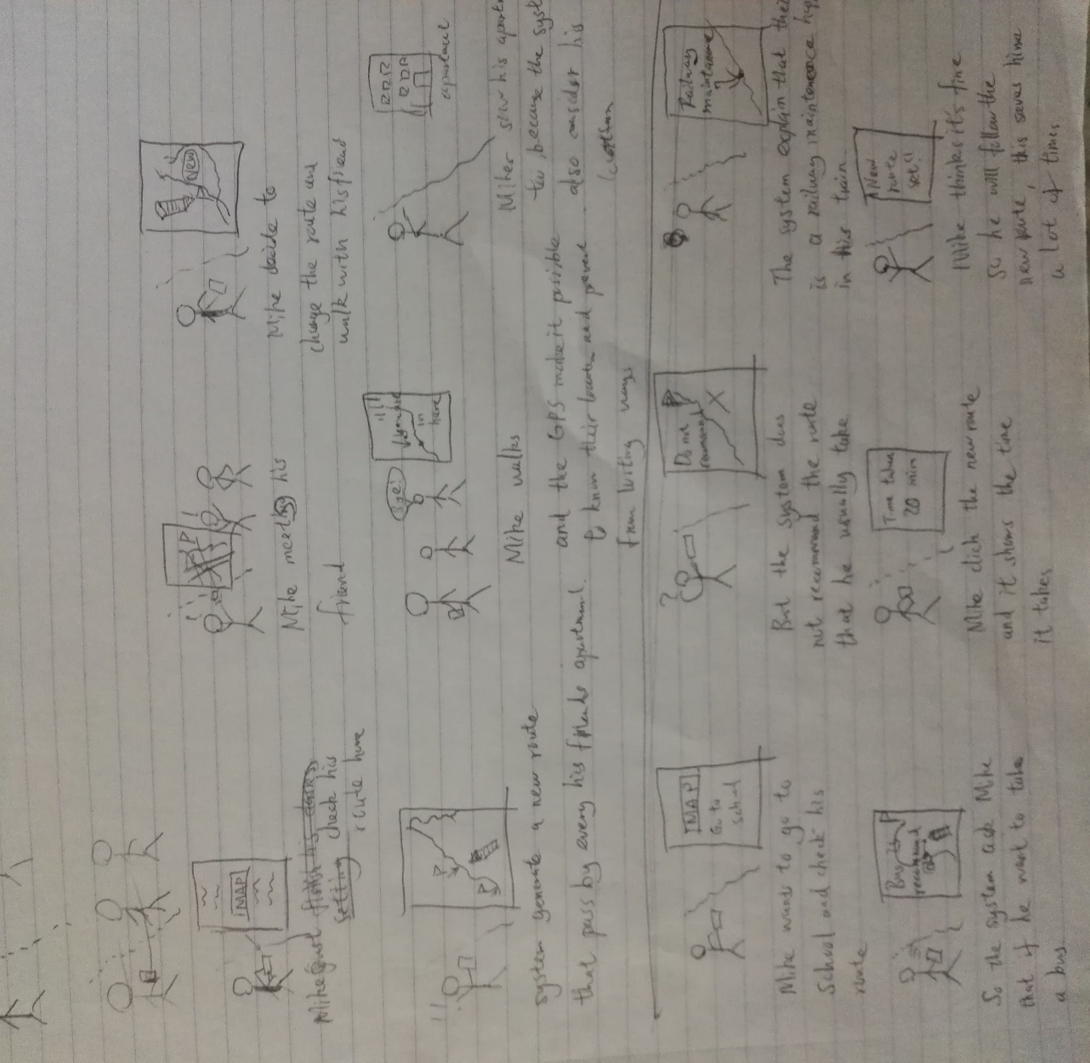

Appendix 4:

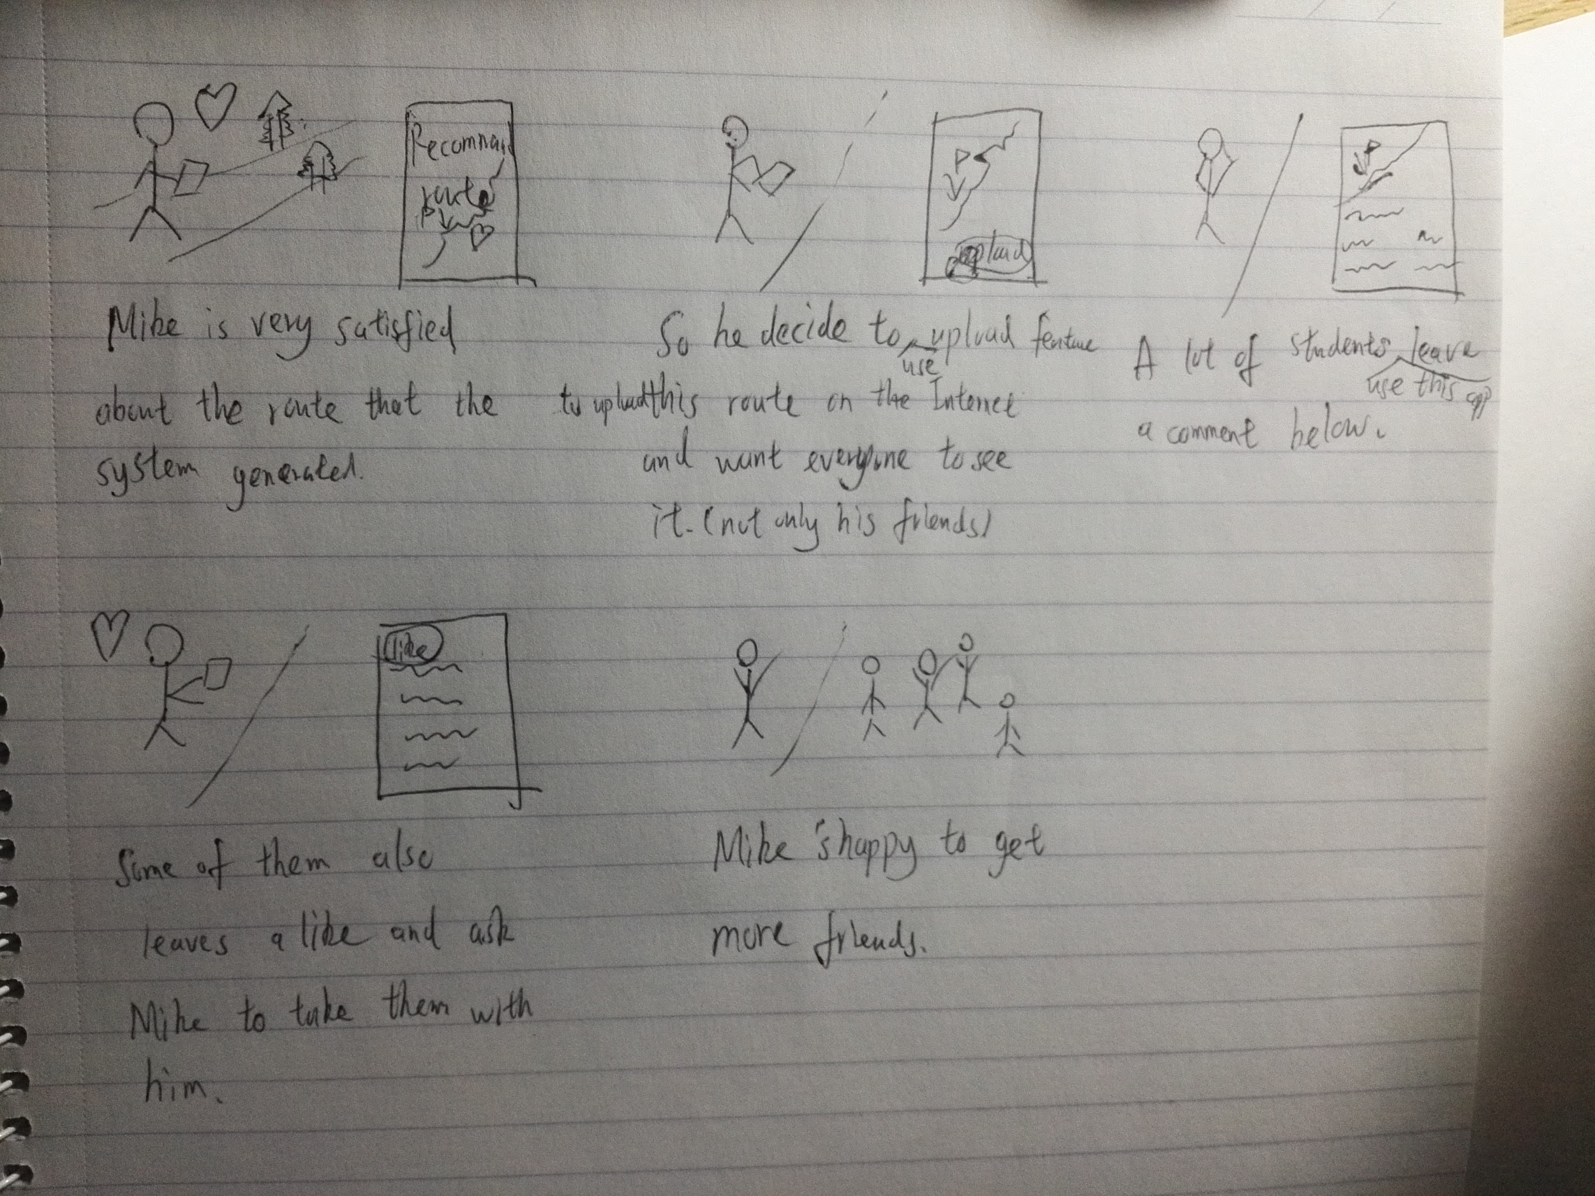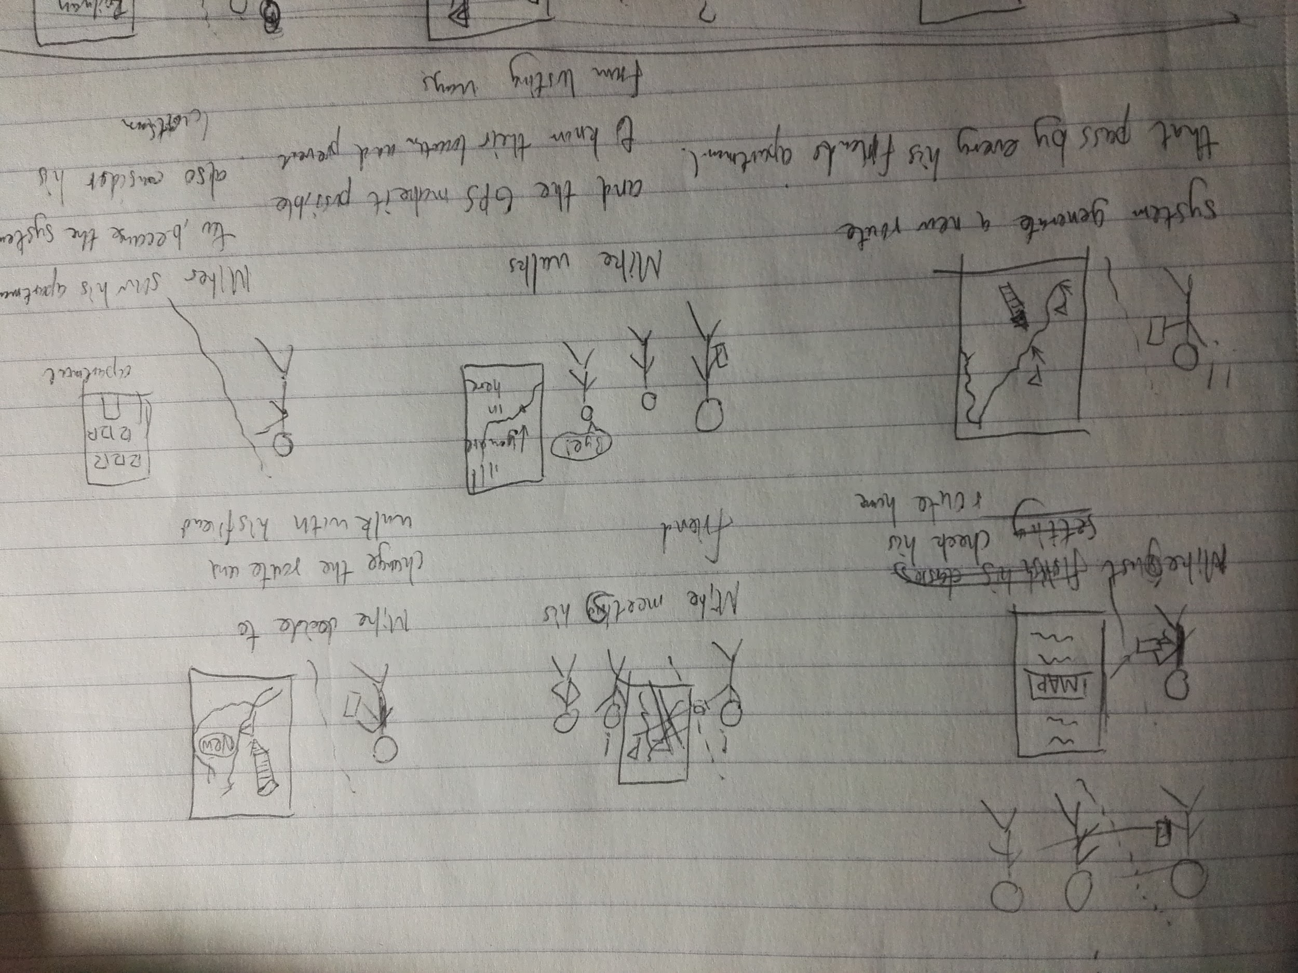

Appendix 5:

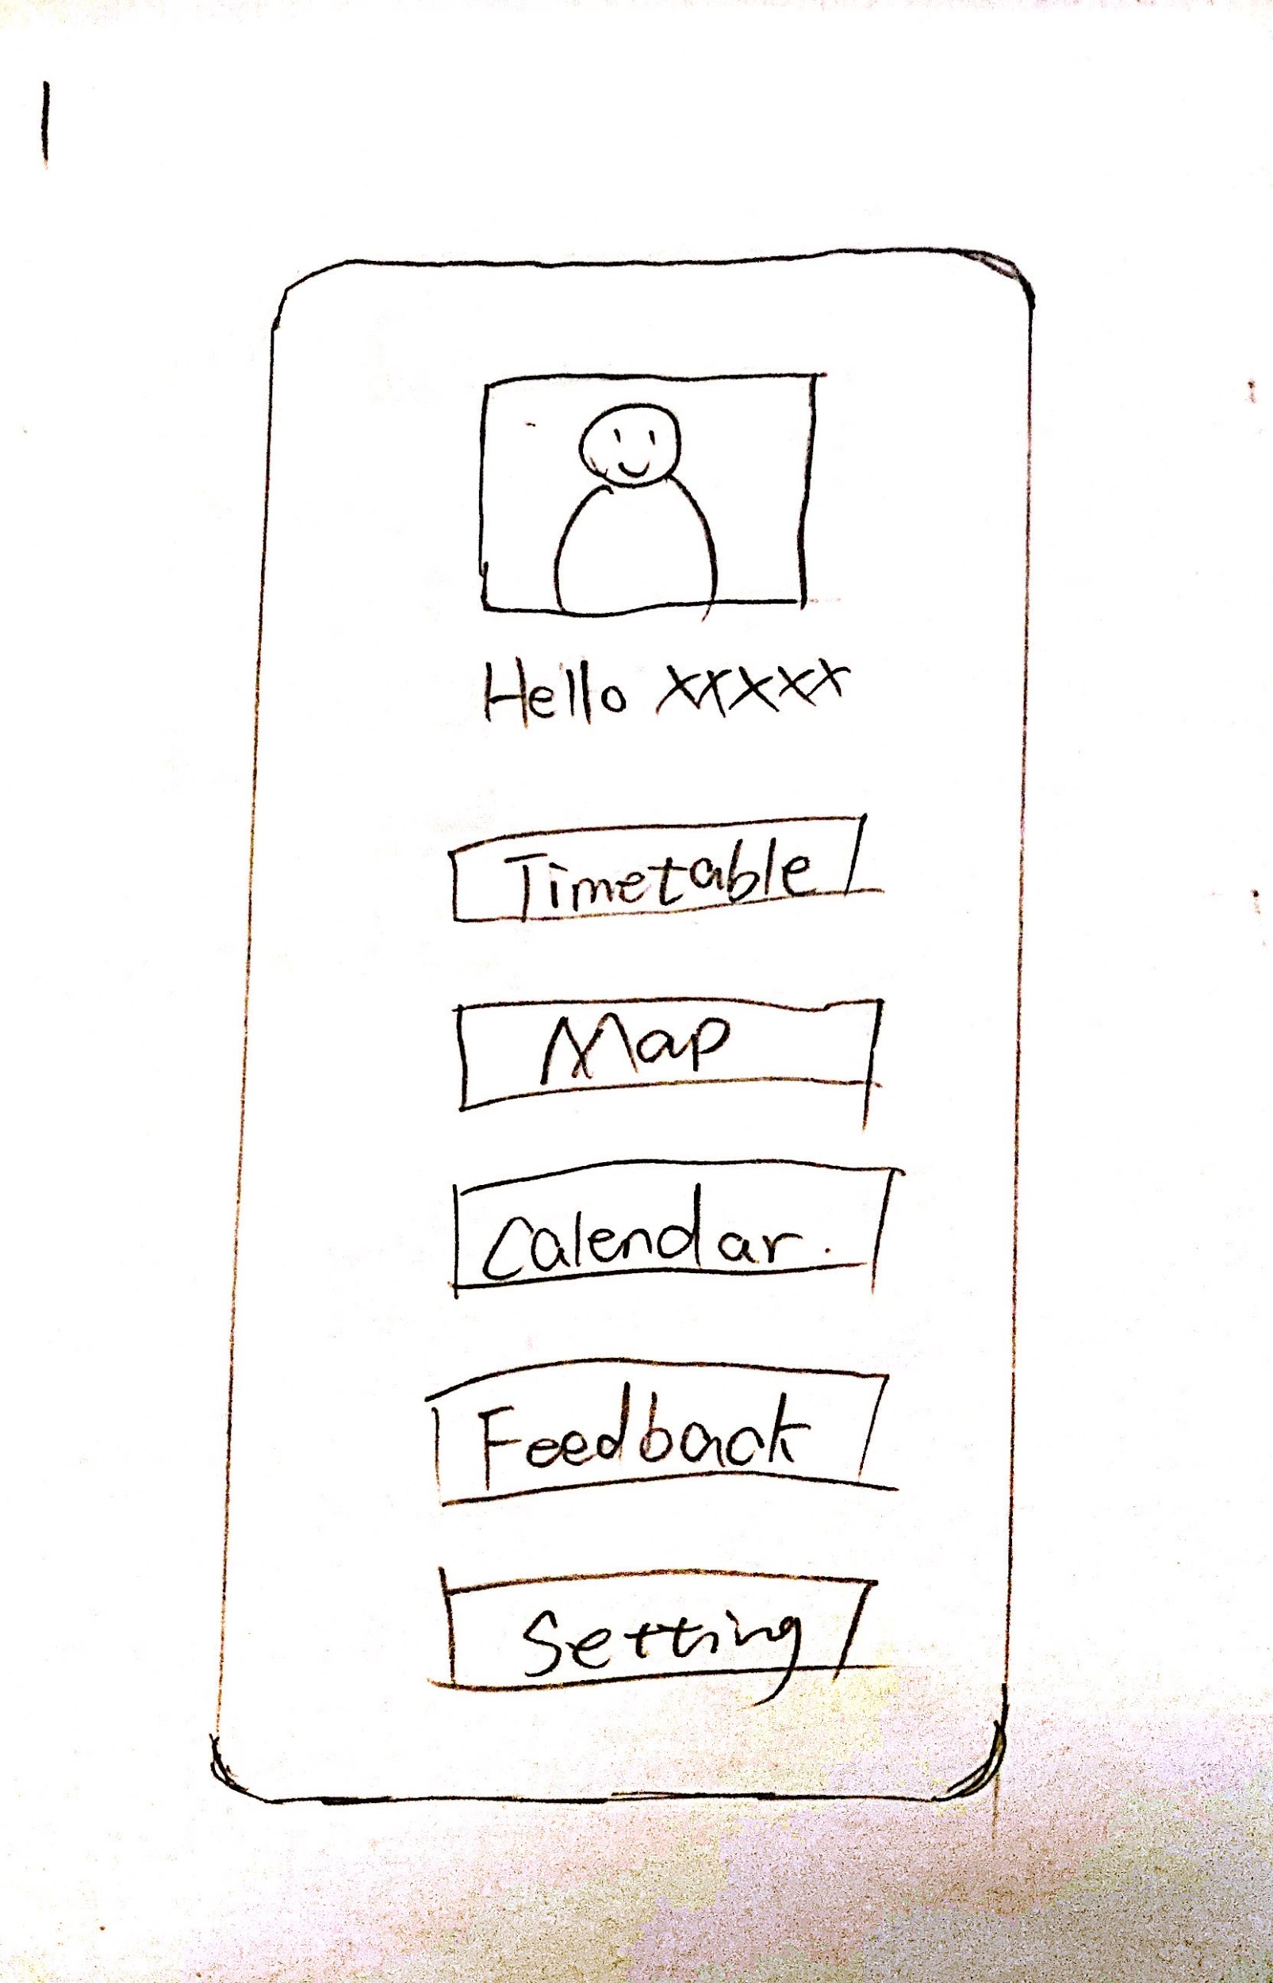

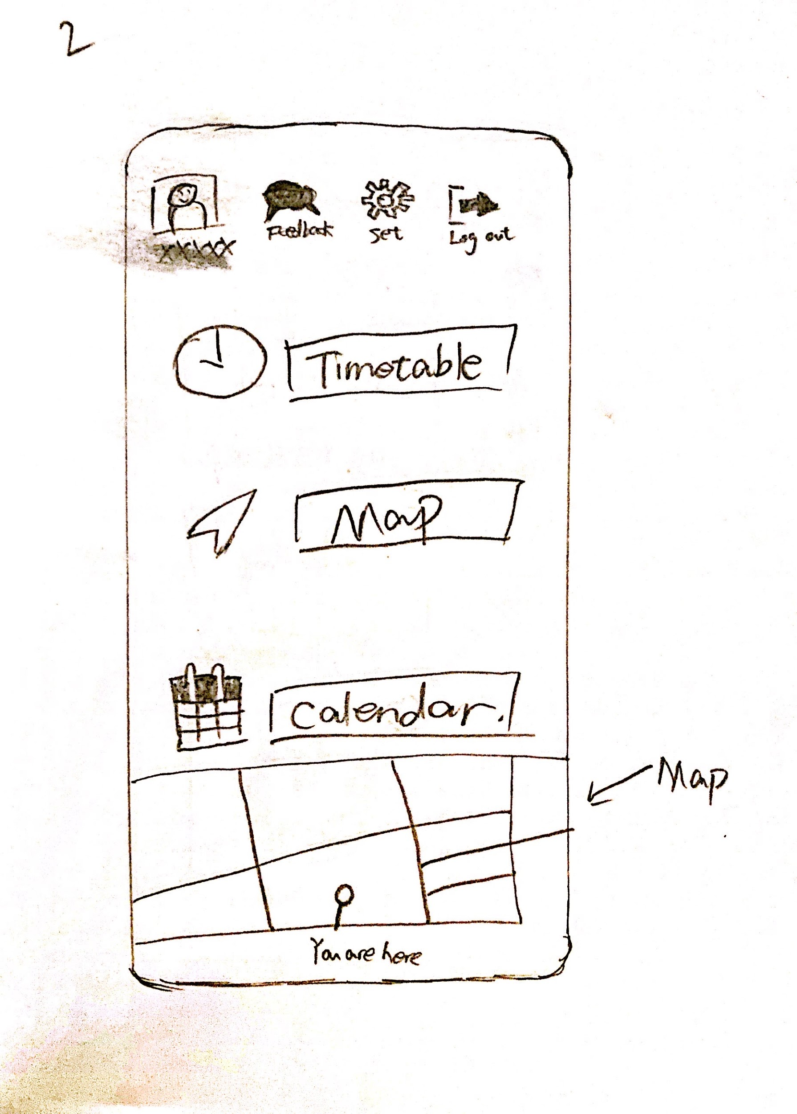

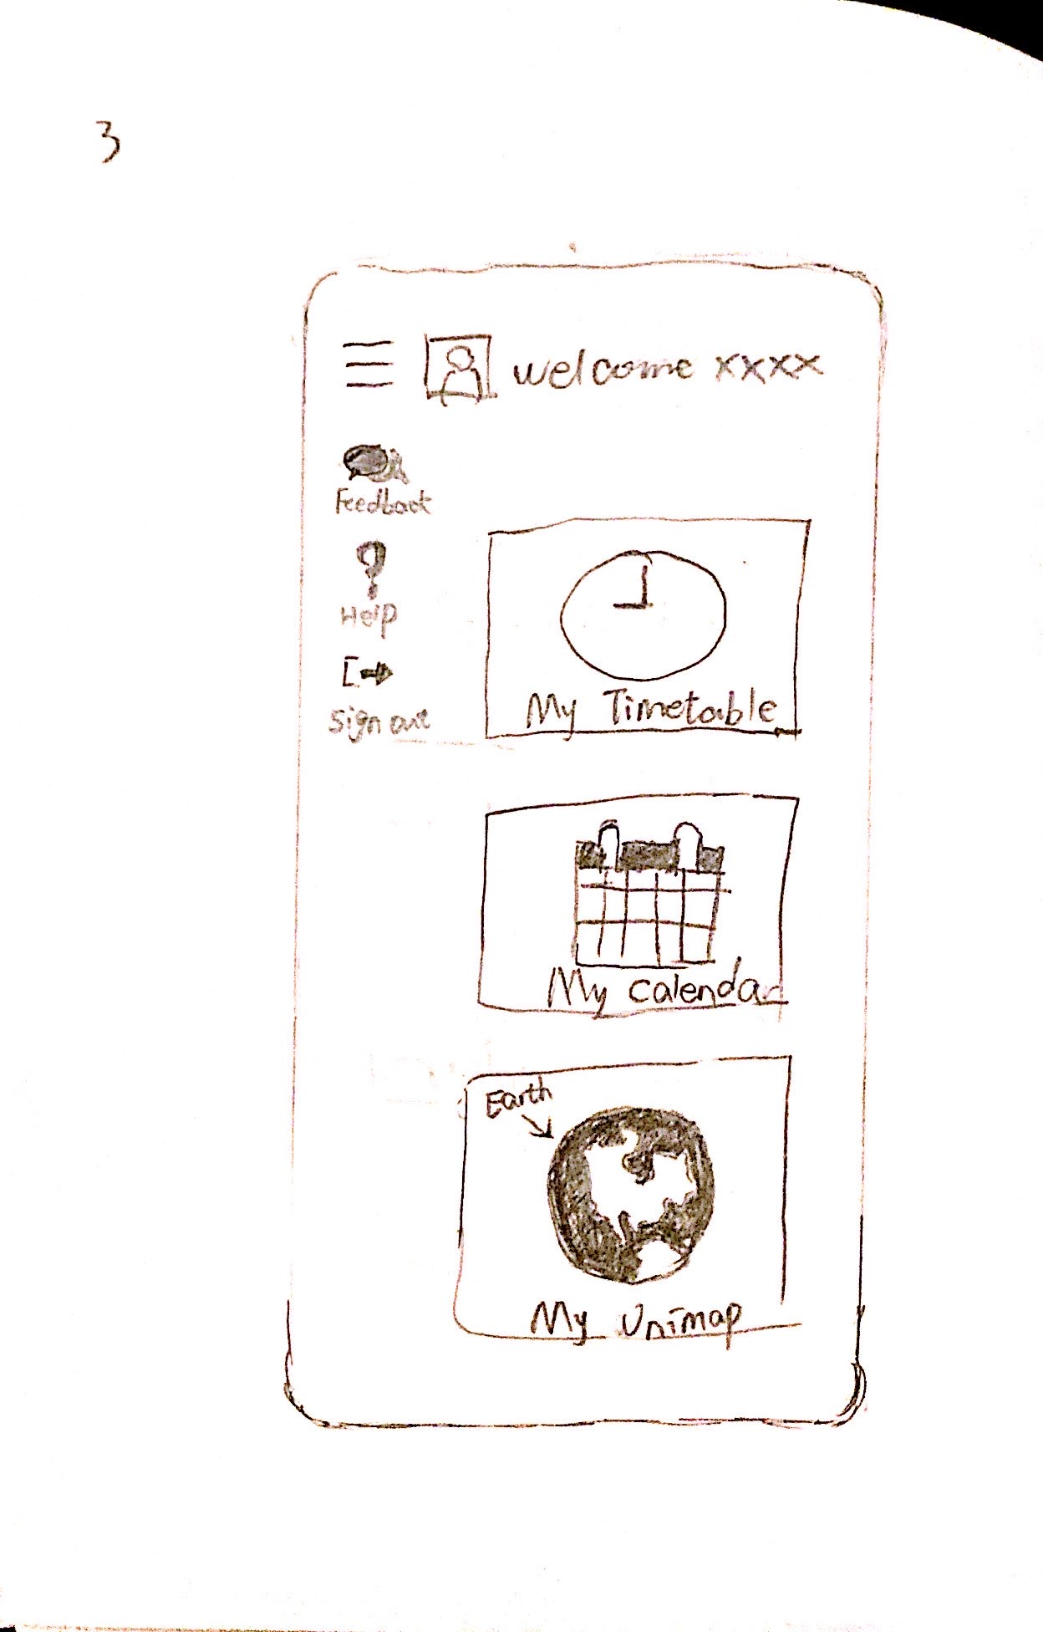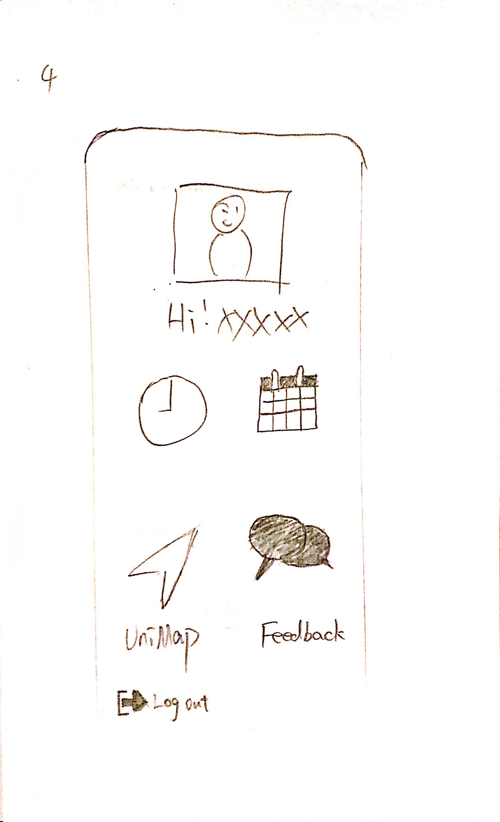

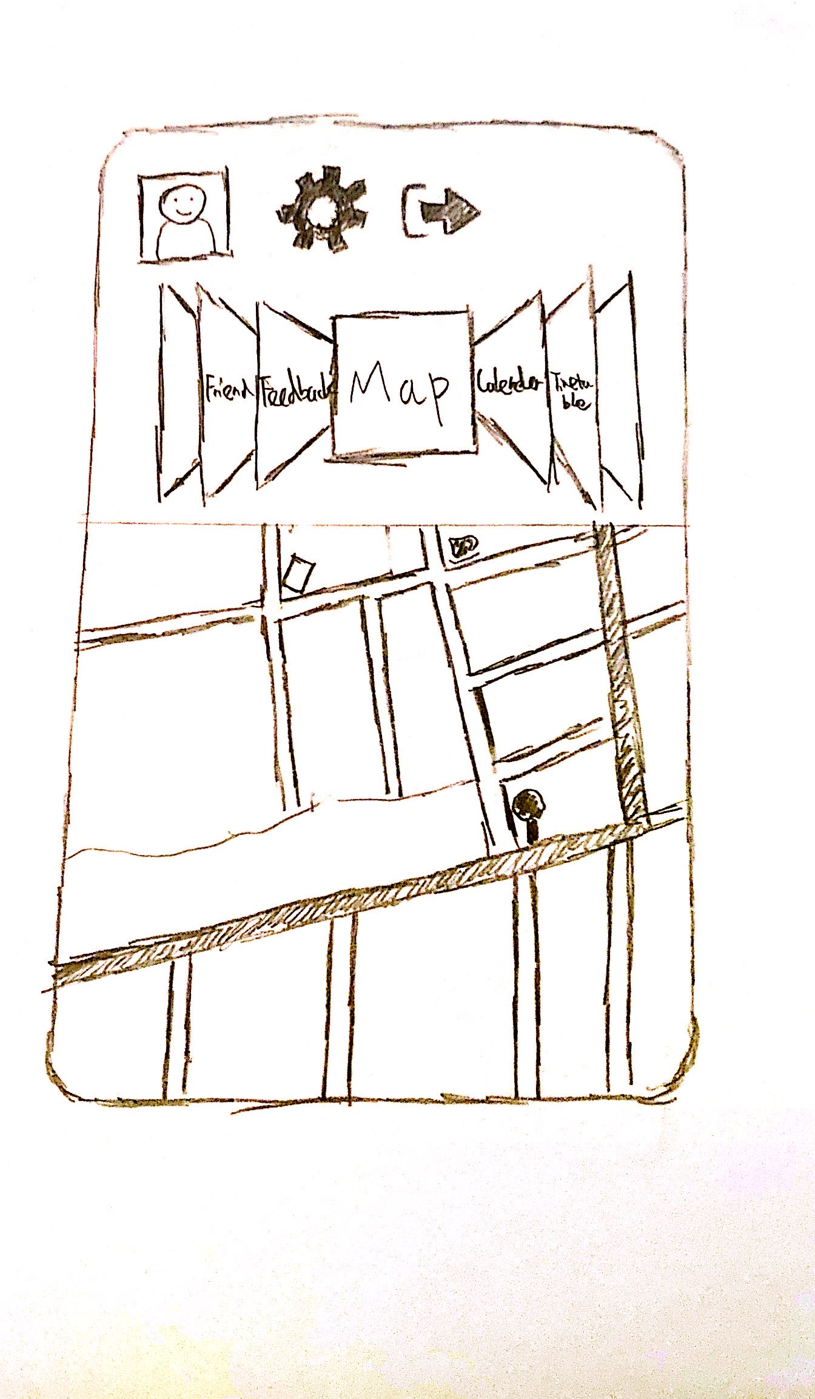

Appendix 6: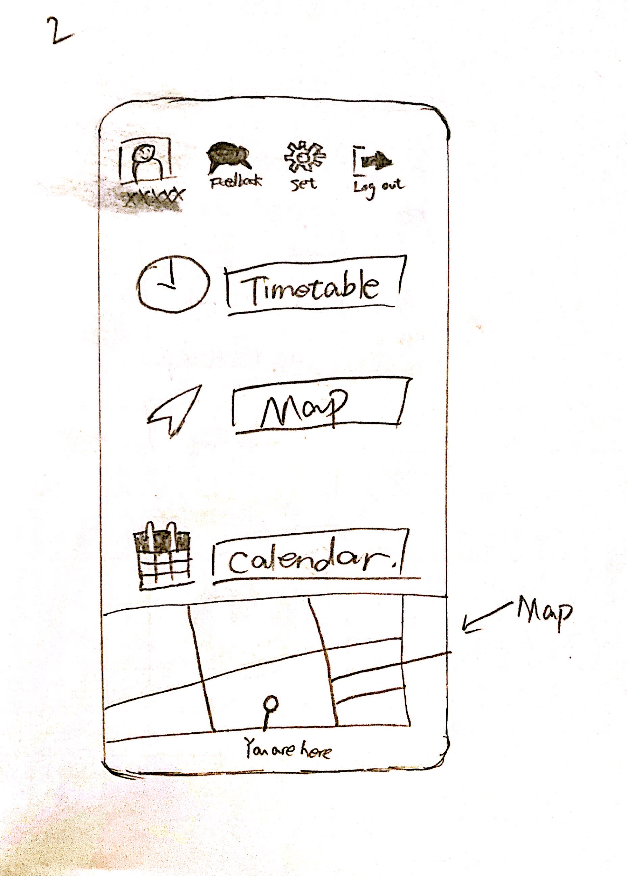

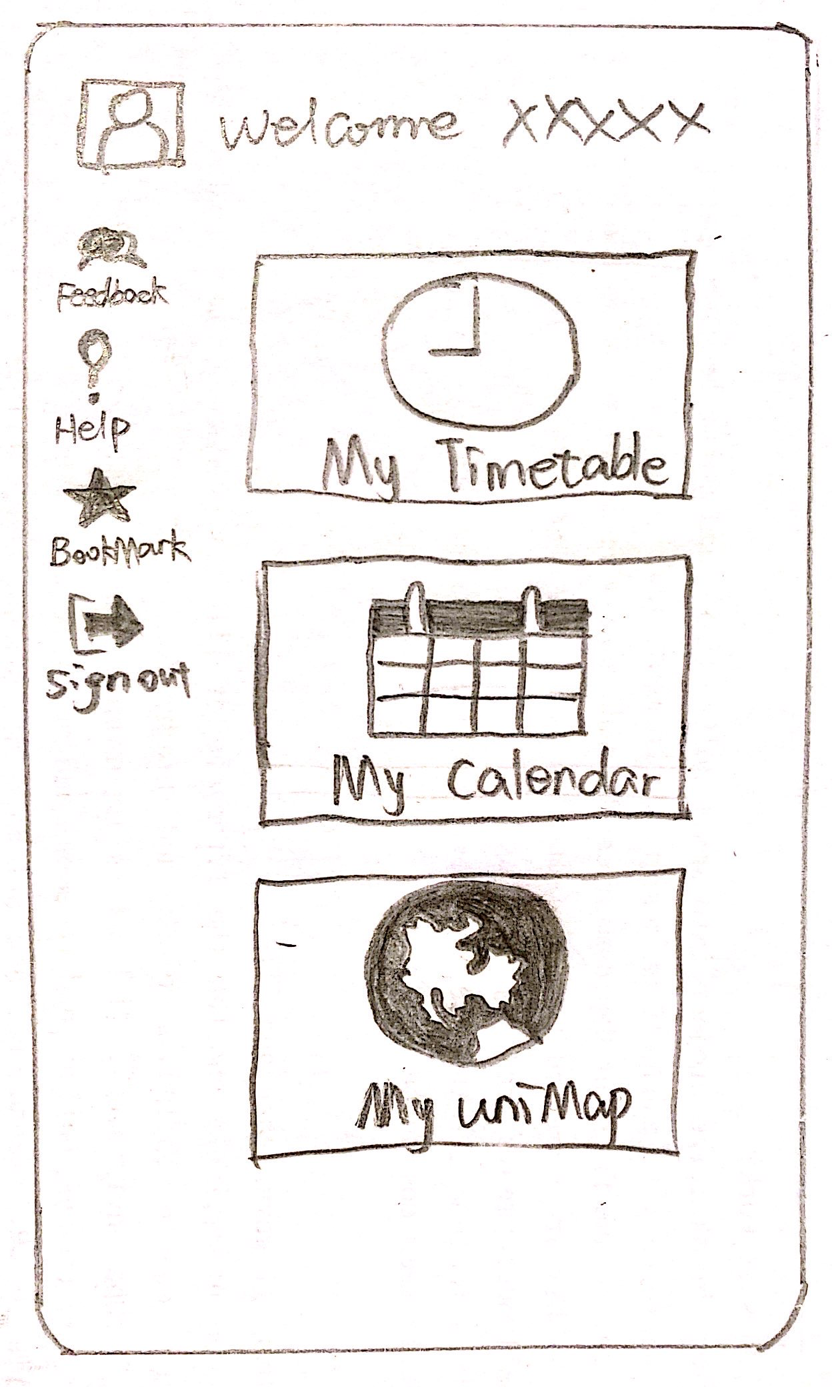

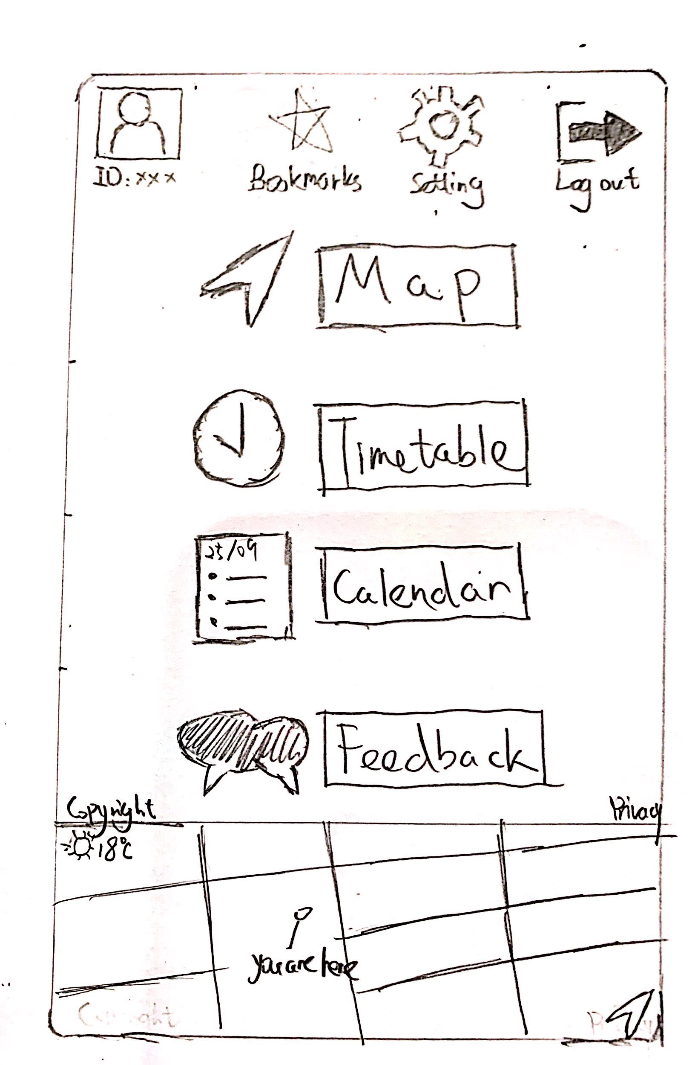Appendix 7:

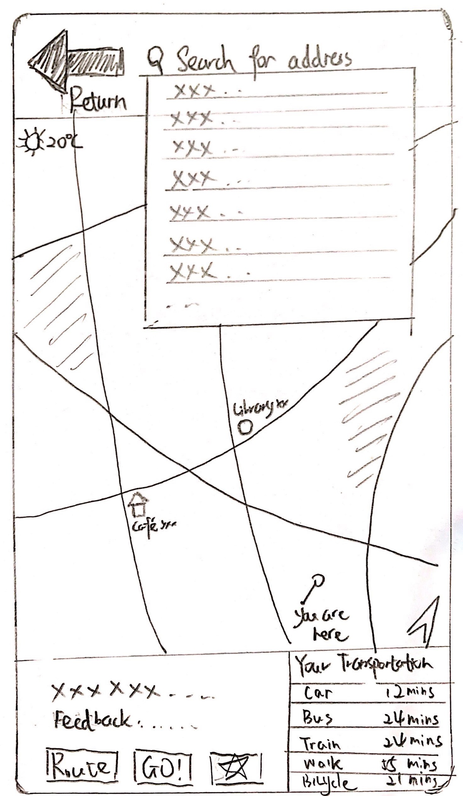

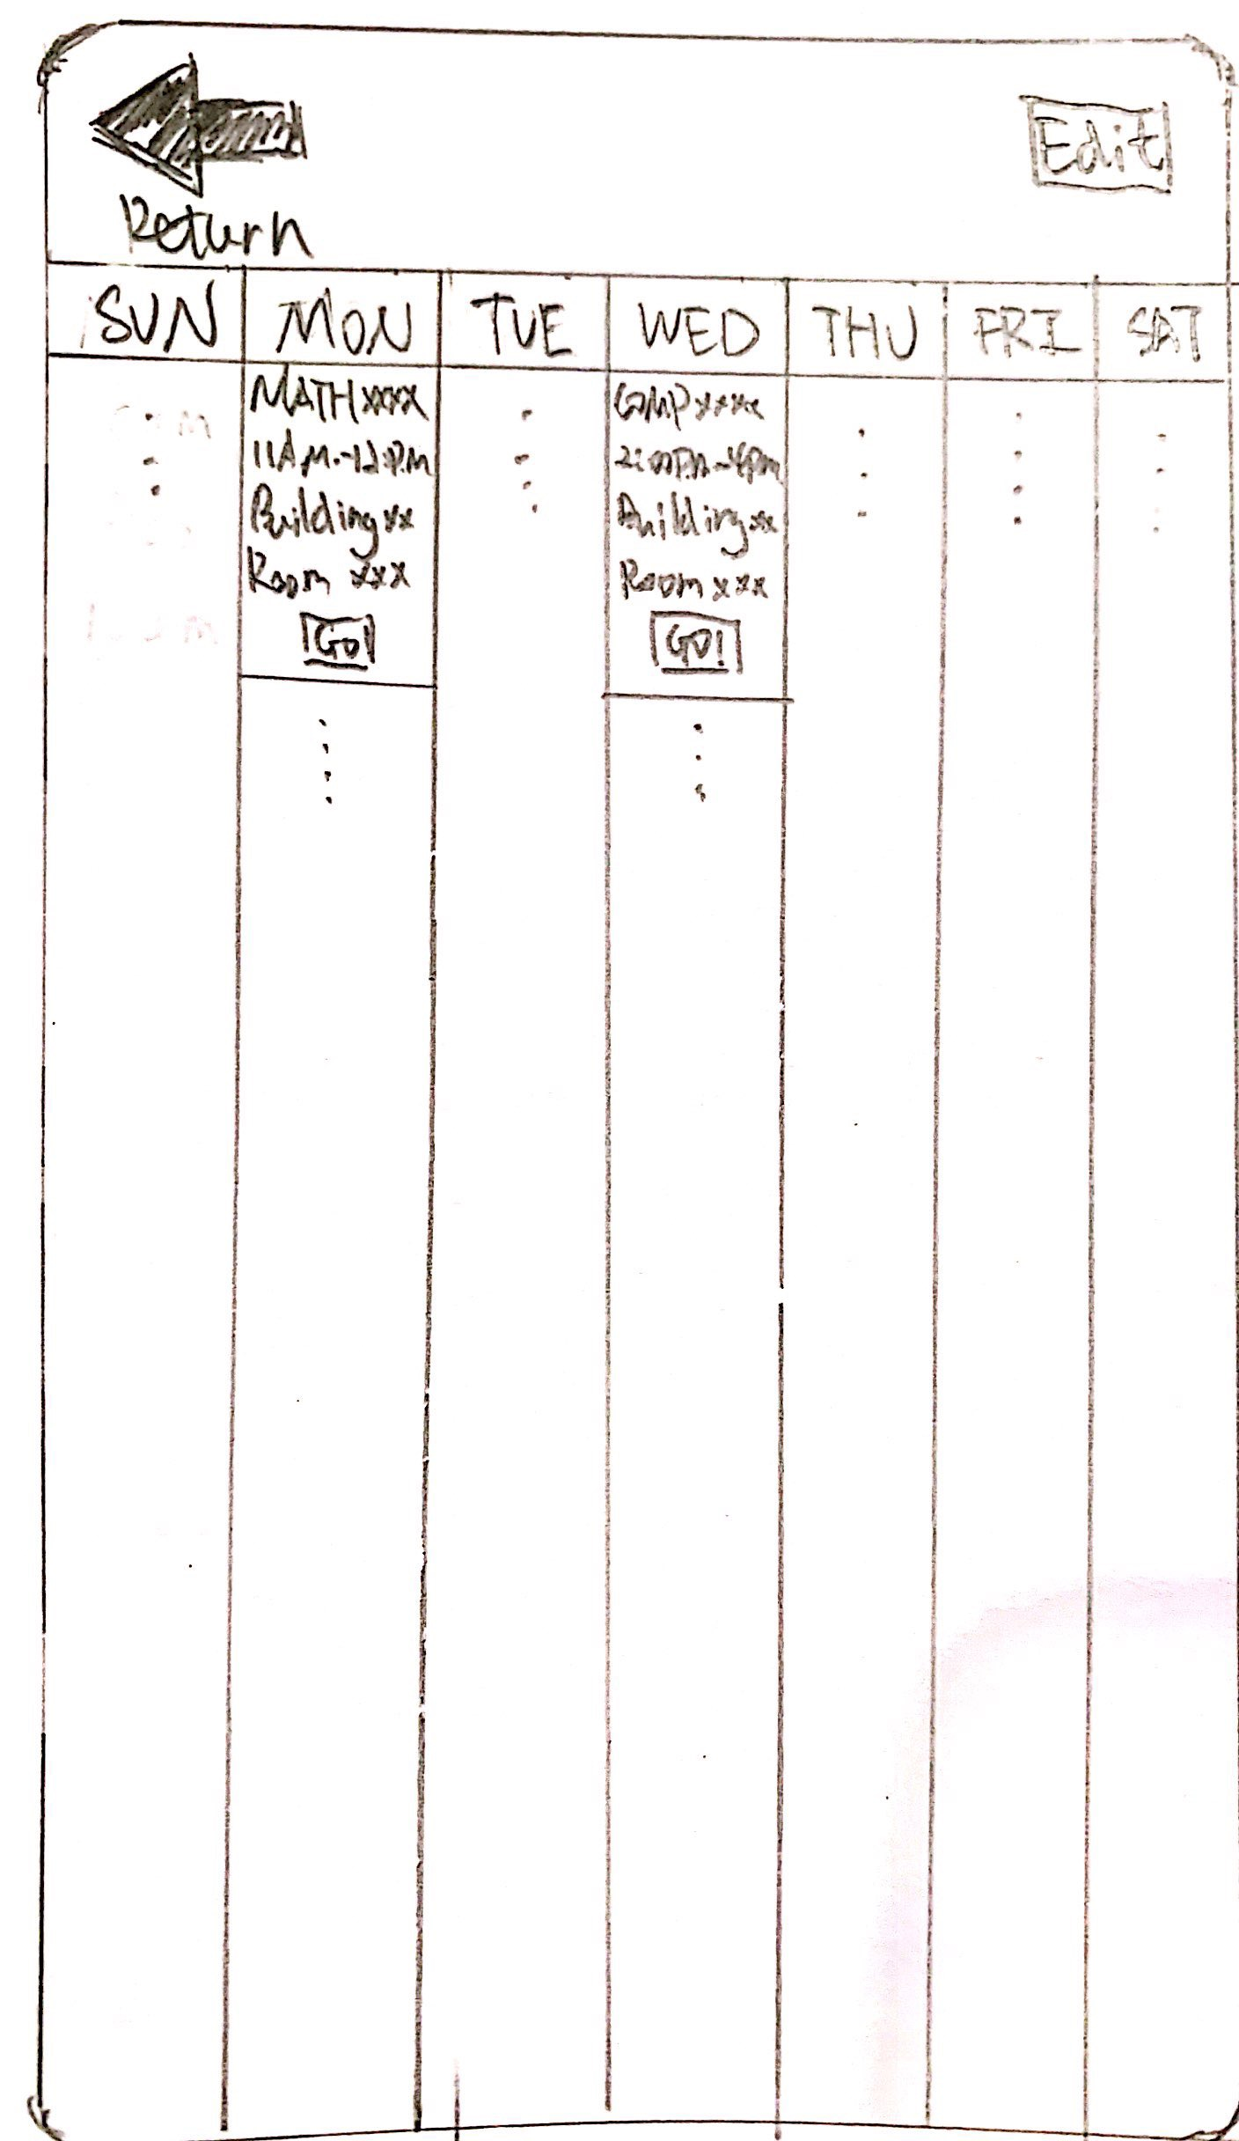

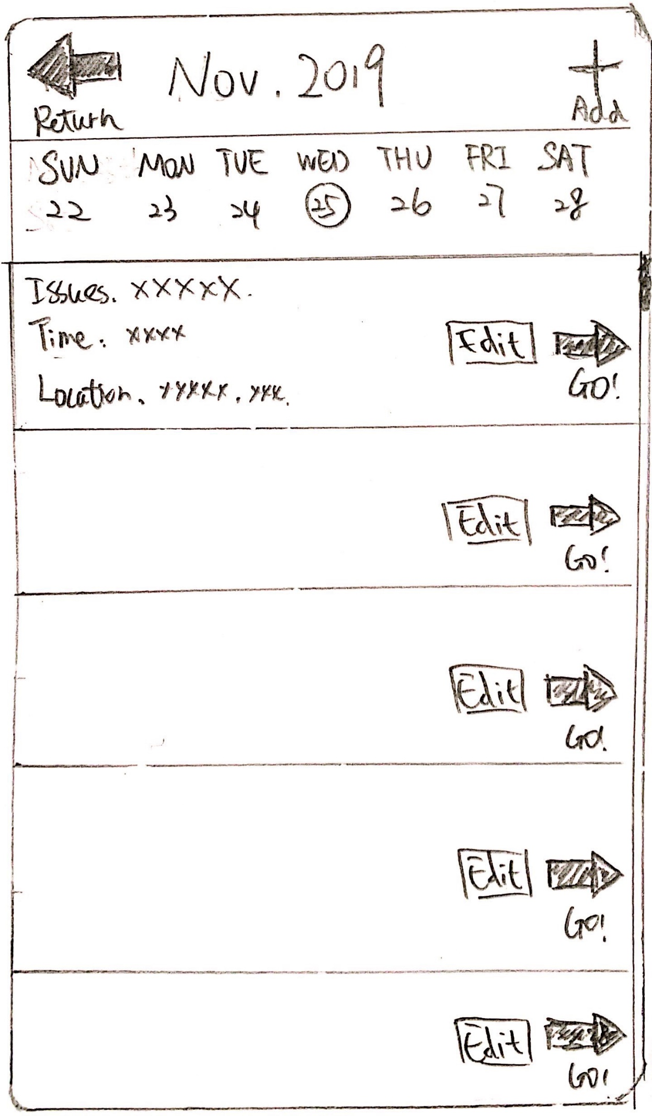

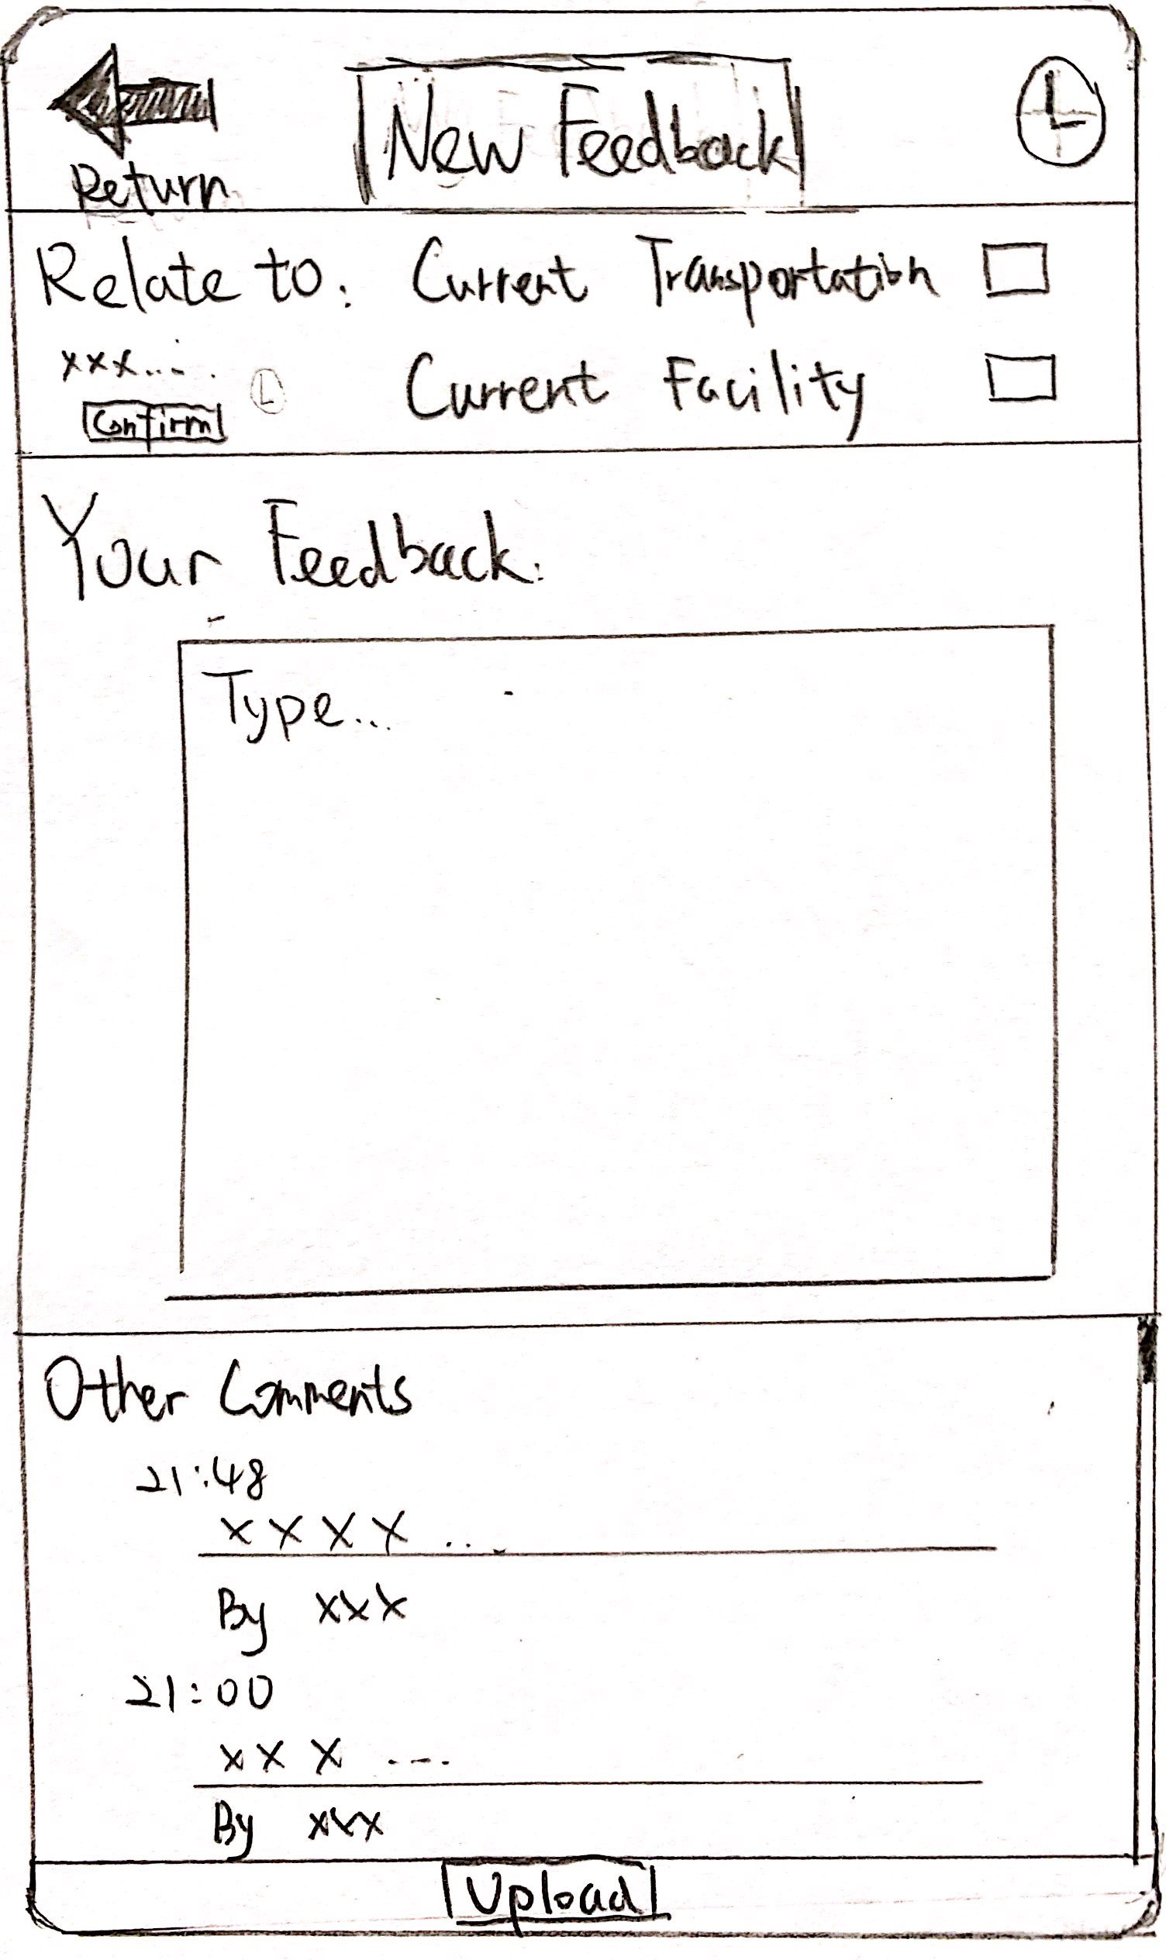

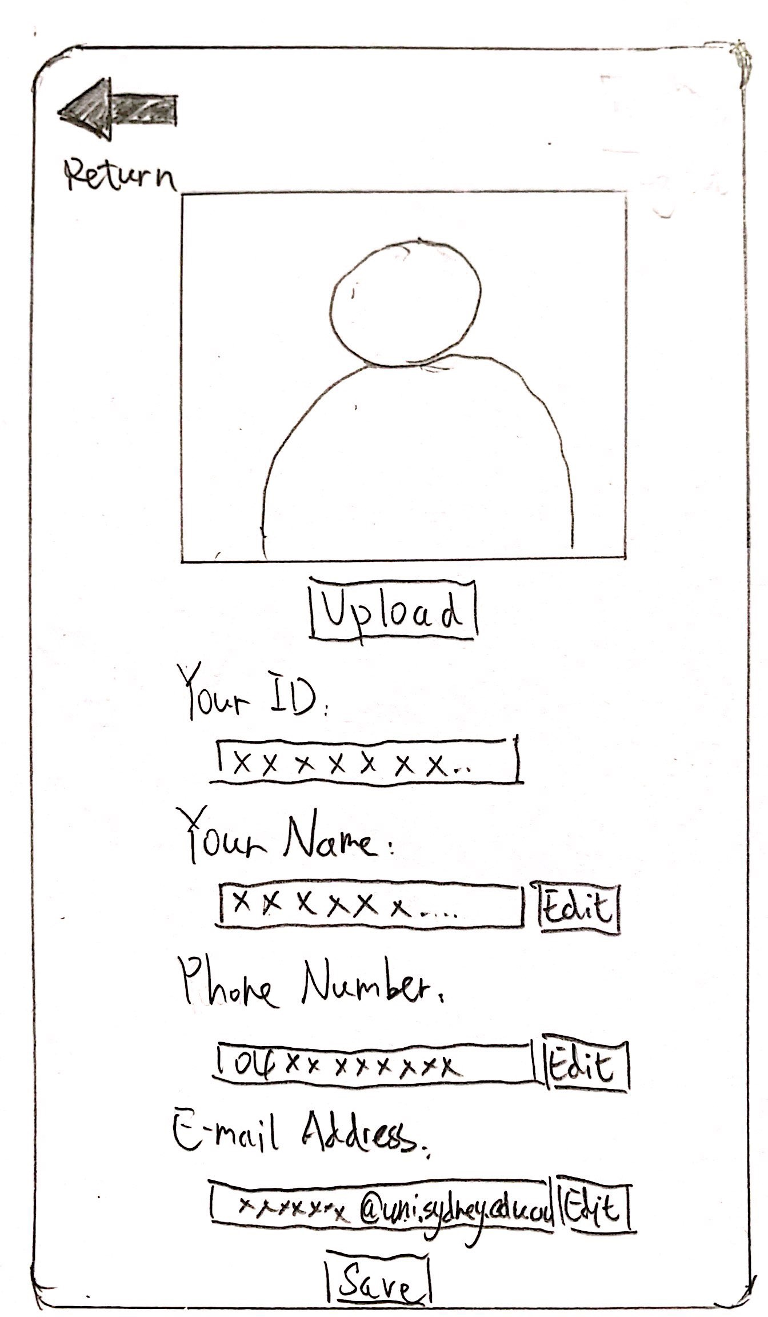

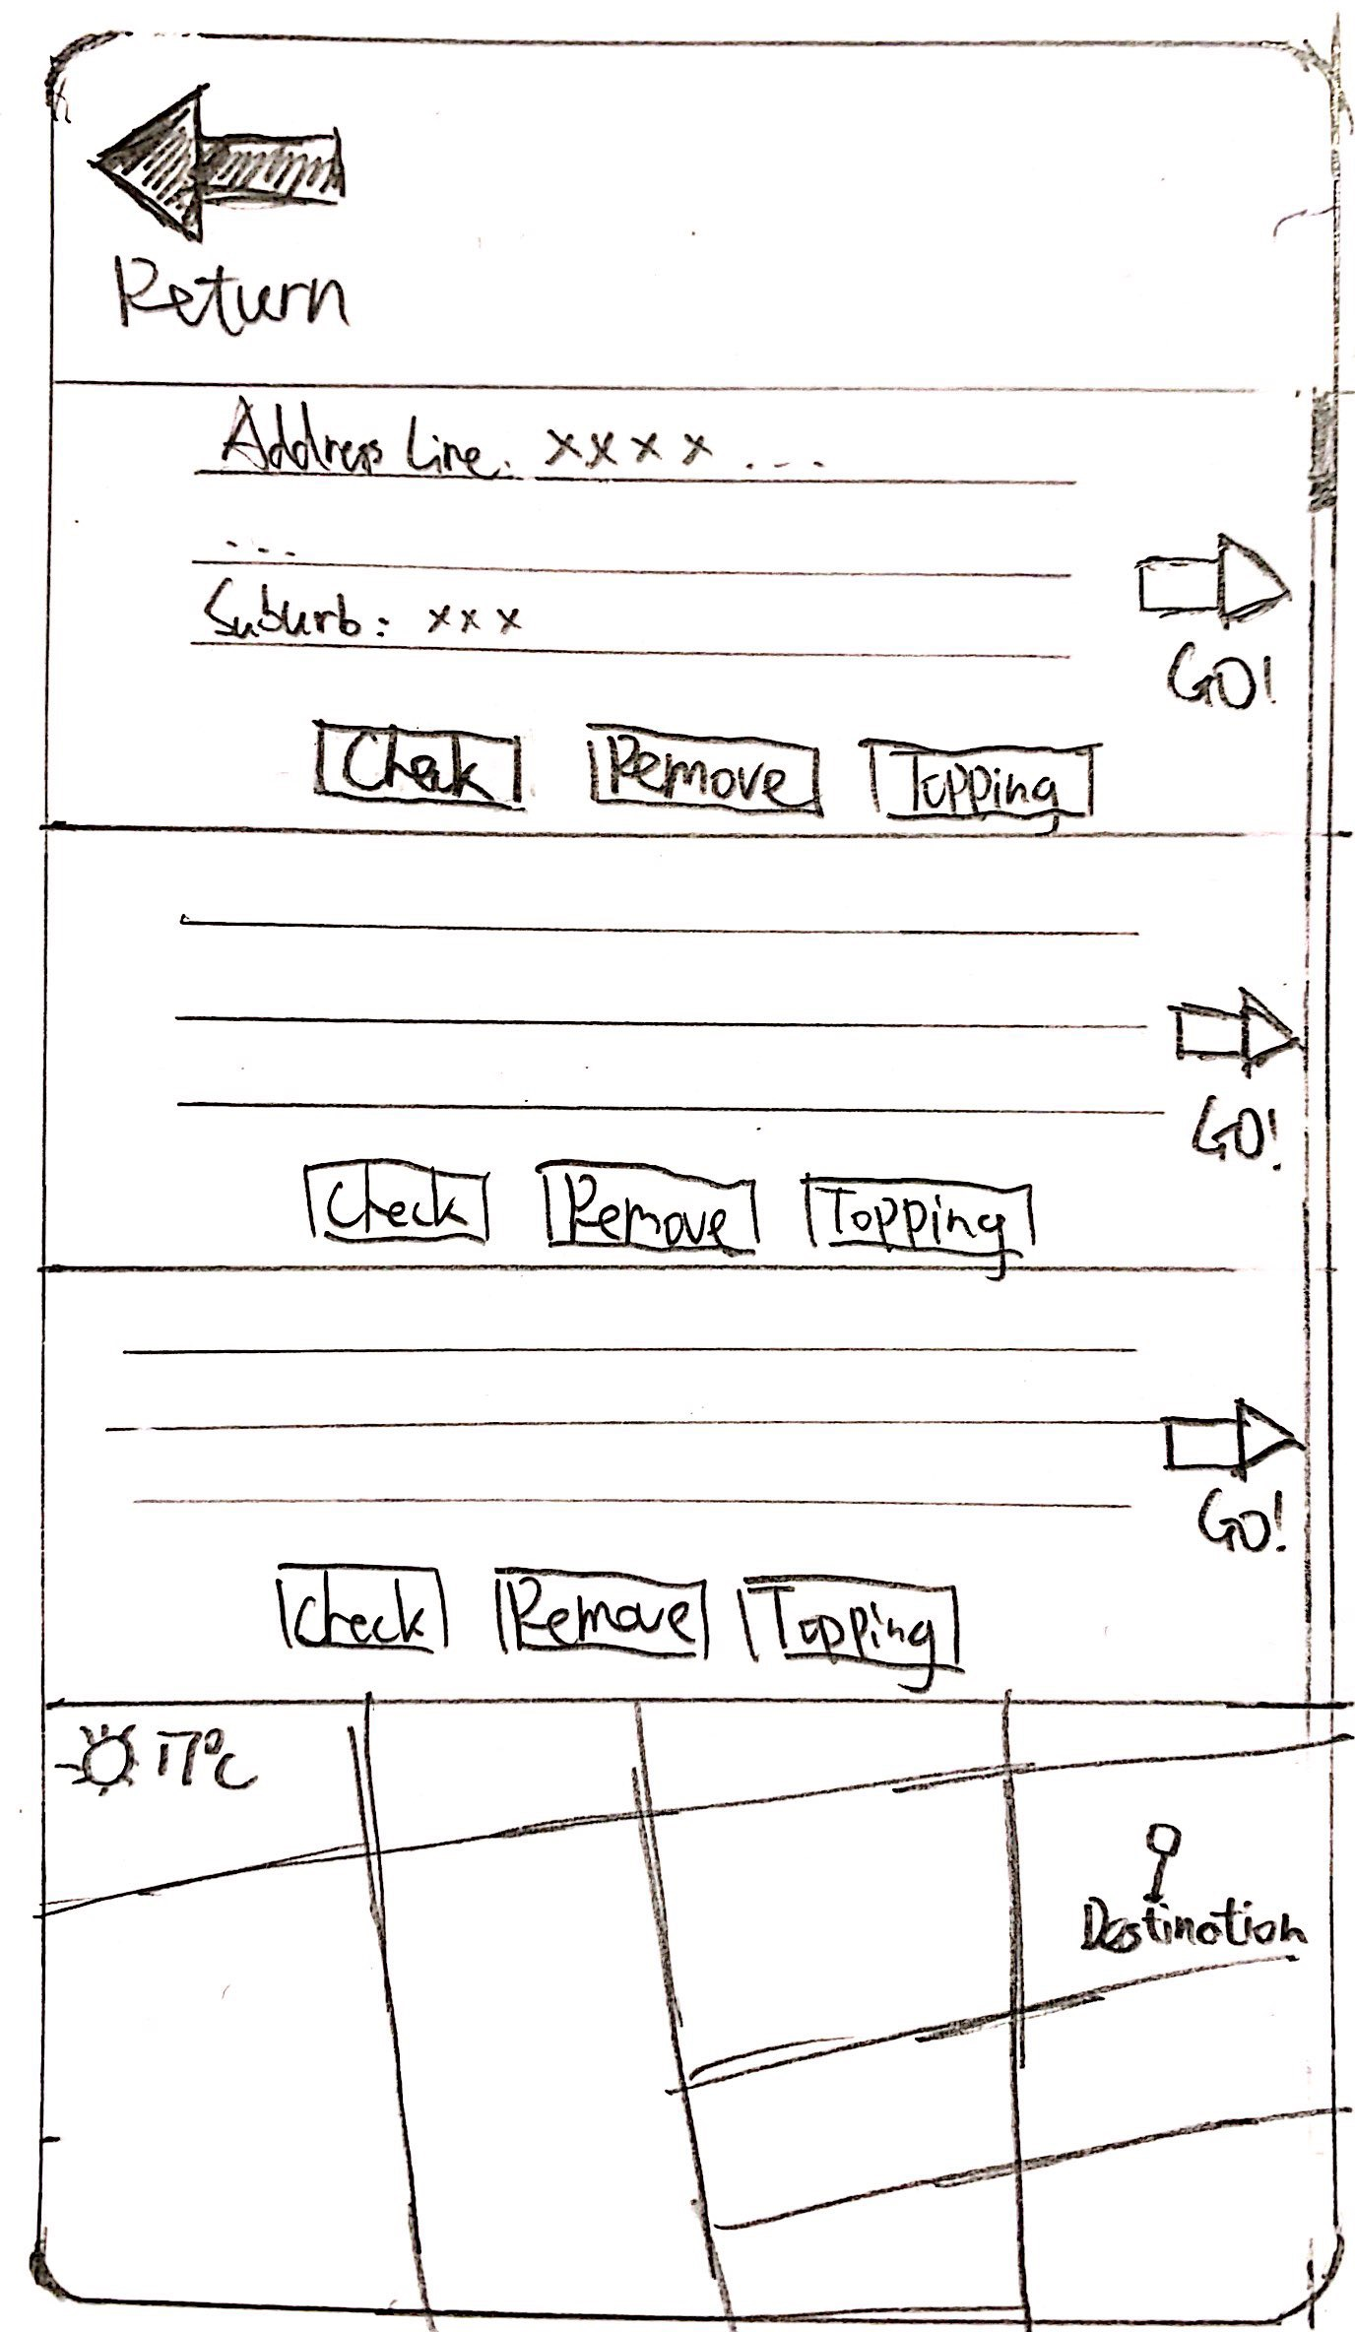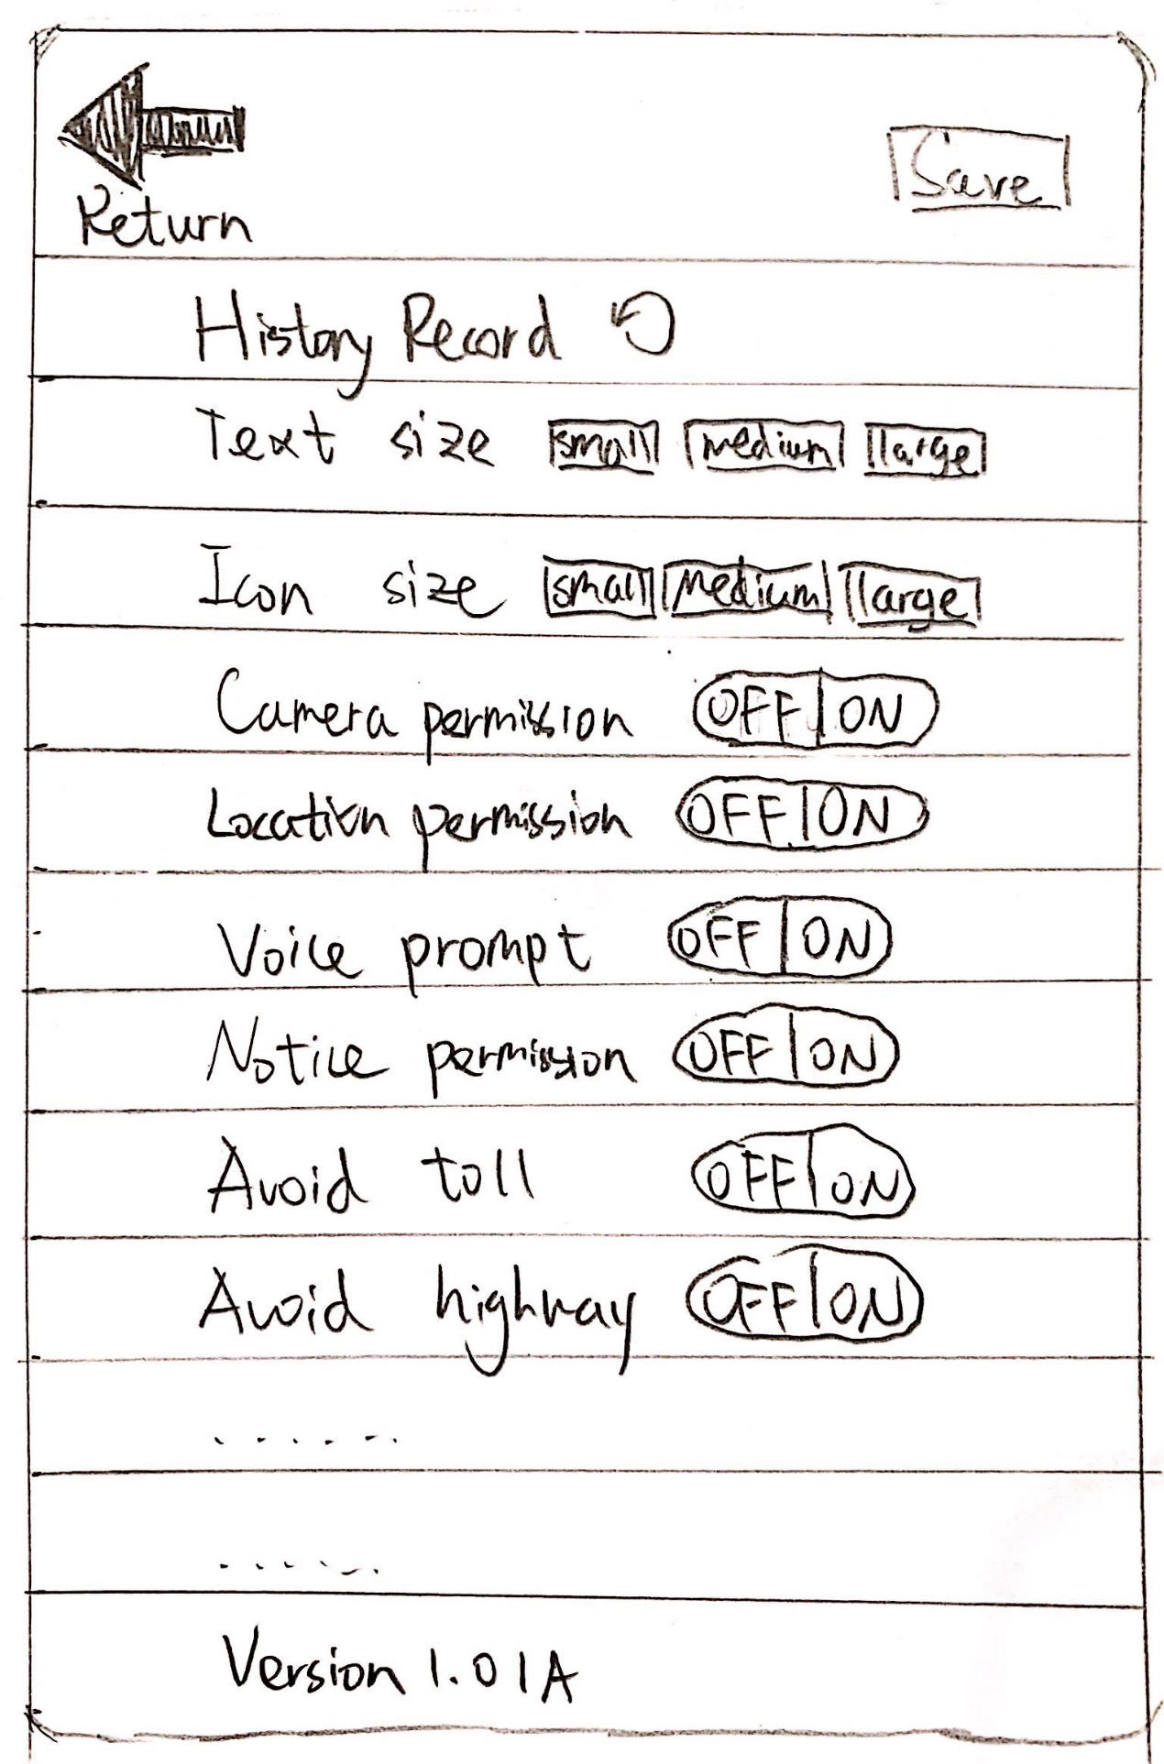

Appendix8:

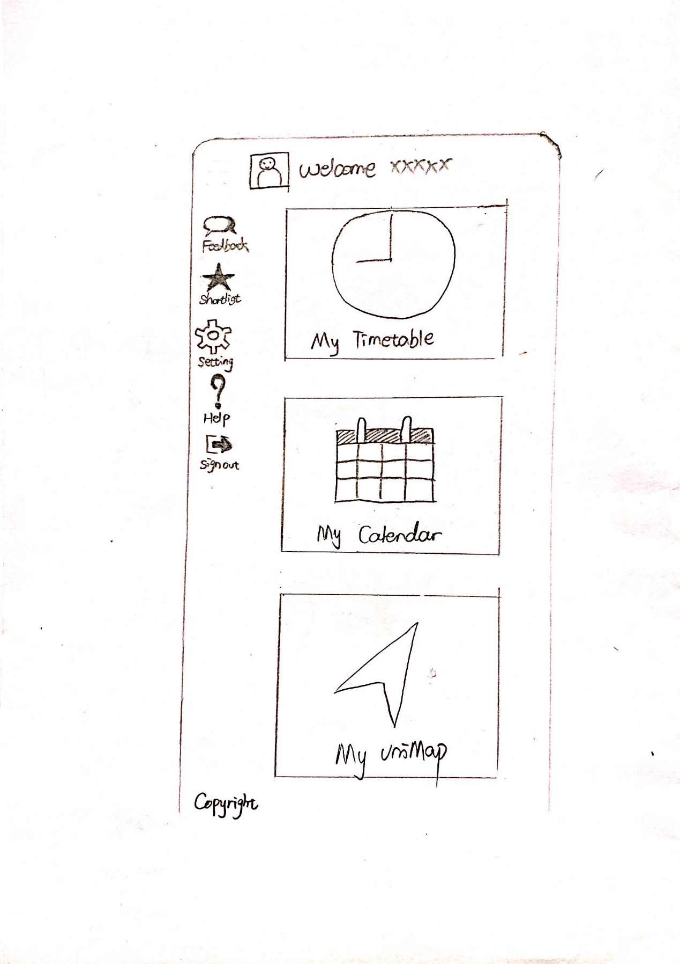

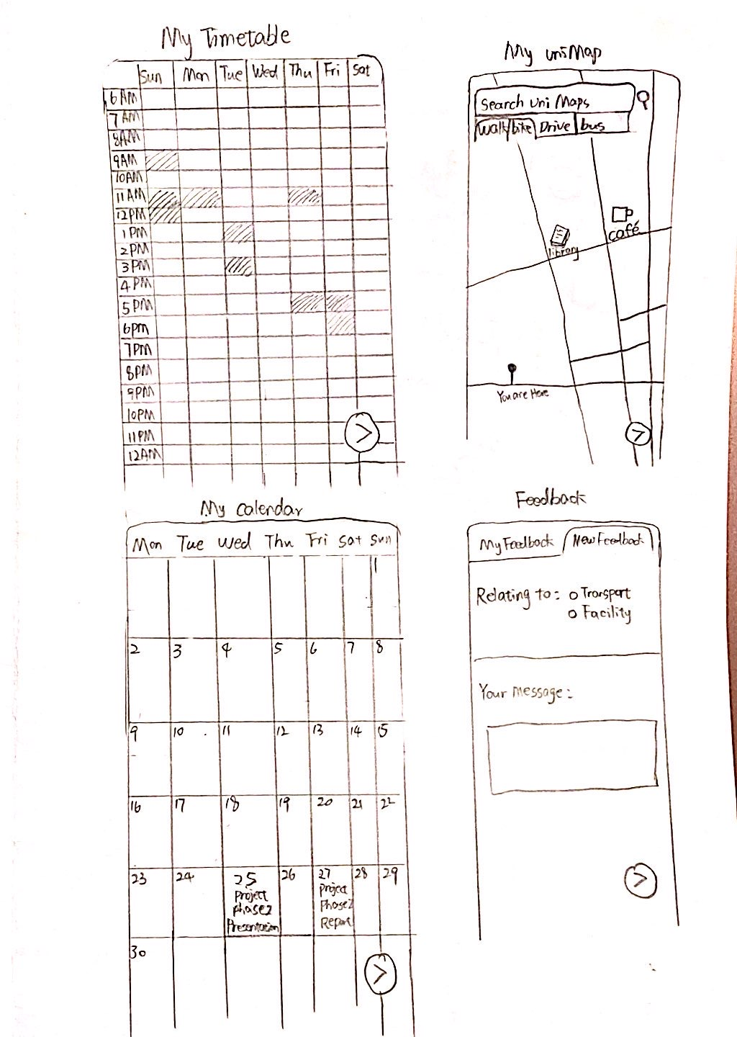

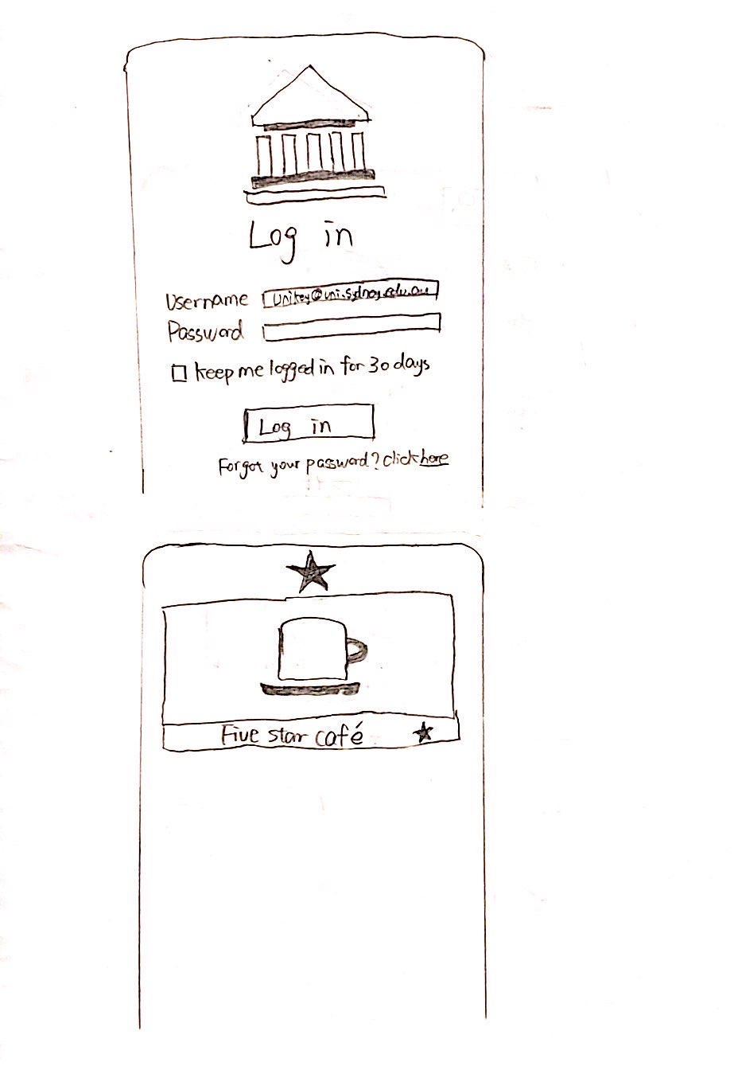

Appendix 9:

